Name | Description | Type | User Group | Issue ID
Configurable graph: Enable legend for PortStyle | It is now possible to include port styles in the Configurable Graph Legend.  <PortStyles>  <PortStyle name="Event" borderColor="#d96f4a" fillColor="#d96f4a" legend="Port with event" legendLabel="p1"/>  <PortStyle name="Port" borderThickness="1" legendLabel="p2"/>  </PortStyles>  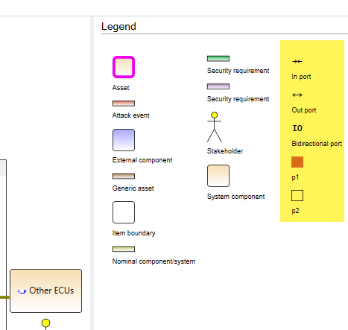 | Improvement | Architect | 16447
DPI: Improved scaling for 4K monitors | This release includes improvements to the scaling of some elements in the swExplorer client on 4K monitors when using 250% display scaling.  - Open Issues in Overview  - Versions view  - Sandbox editor  - New issue attribute labels  Further improvements are planned for later releases. | Improvement | User | 16489
Coverage item>item: support for multi select mapping on left side | It is now possible to multi-select on the left-hand side and manage mapping.  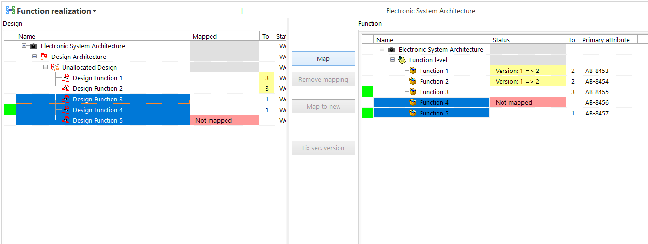  If one or more of the selected items on the left-hand side are "Released", the Map button will not be available. This means that if any one of them is "Released", the mapping operation will not be possible for any of the selected items.  If multiple items are selected on one side, and there is a version mismatch, the Fix sec. version operation will only be completed if all the selected items, on both the left-hand and right-hand sides, have the same type of issue. Otherwise, the button will be disabled. | Improvement | User | 16643
Views: Introduction of Snapshot view | This release includes a first version of a new view called the Snapshot view.The view can be used to display a variety of information, such as Attributes, Description, Properties, and Traceability, Attachments, etc. for an item structure (based on a configuration) - all in one place. For more details, see the application Help.  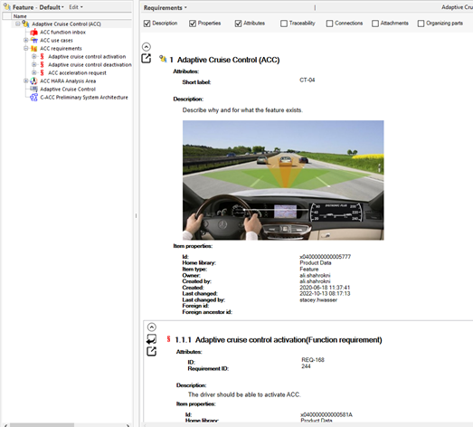  Known limitation: Only jpg and png images are shown in the current version.  The view will be delivered as a standard extension with all named releases. | Improvement, | User | 16456
REST API: Upgrade to .NET 6 | The SystemWeaver Rest API has been upgraded to .NET 6. The server machine must have .NET 6 or later installed to run the Rest API. This is a breaking change if the machine is running an older version. | Improvement | Rest API, IT Administrator | 16469
swExplorer: Change to Latency indicator | The latency indicator at the bottom right of the swExplorer client has been renamed to Ping. It now displays a more accurate latency between the client application and the SystemWeaver server application and back. As before, this indicator can help diagnose potential internet connectivity issues. When logging in to a server located on the same computer as the client, the Ping will now show 0 ms. Typical latencies are approx. 10 ms for LAN access, and 100 ms for cross continent or global distances.  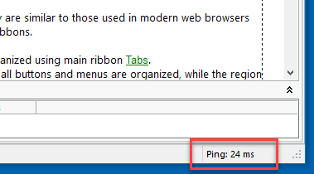 | Bug fix | User | 16708
Jira: Support for Jira Cloud | The Jira integration is now available for use with Jira Cloud. A SystemWeaver button displays in Jira Cloud as shown below.  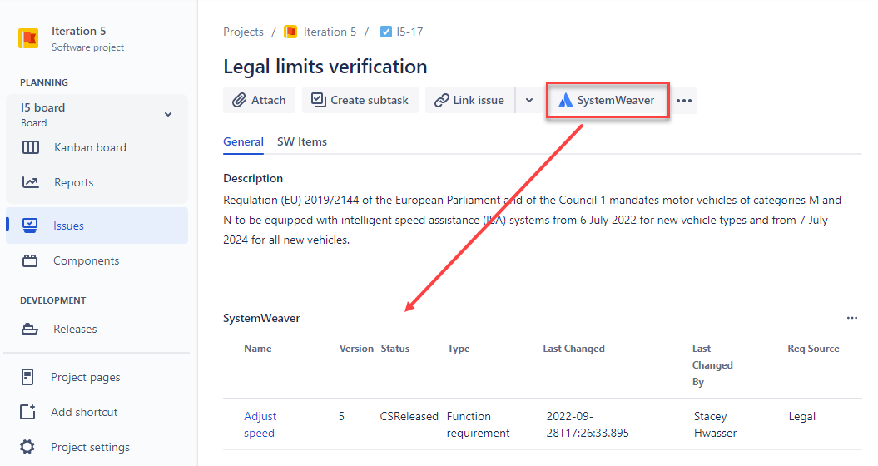  If switching your installation from Jira Server to Jira Cloud, add the OverrideScreenSecurity="False" attribute to the existing <Jira> tag in your Jira extension view configuration in SystemWeaver.  <JiraConfiguration>  <Jiras>  <Jira OverrideScreenSecurity="False">  <Name>Head-office</Name>  <BaseUrl>http://jiraserver:8085</BaseUrl>  <MainProject>ESP</MainProject>  <CustomField>customfield_10200</CustomField>  <Relationship Floating="True/False" />  <Epic>  <EpicTypeId>10001</EpicTypeId>  <CustomField>customfield_10004</CustomField>  <EpicName>Epic issue</EpicName>  </Epic>  </Jira>  </Jiras>  <ItemType>I,SID2,SID3</ItemType>  <ServerCode>DEMO</ServerCode>  </JiraConfiguration>  Note that there are no changes to the SWExtension.Jira2.dll extension view file for the swExplorer client. The file can be used with either Jira Server and Jira Cloud type of installation. | Improvement | IT Administrator | 14122
Extensions: ICSharpCode.AvalonEdit no longer delivered | SystemWeaver will no longer deliver the ICSharpCode.AvalonEdit.dll (v 6.1.3.50) which up until now has been included in SystemWeaver Client deliveries. If you have used this dll provided by SystemWeaver in any inhouse built extension views, you will need to include this file yourself in swExplorerExtensions.  Note that if your extension view uses a version earlier than 6.1.3.50, your extension should be placed in a subdirectory as illustrated below:  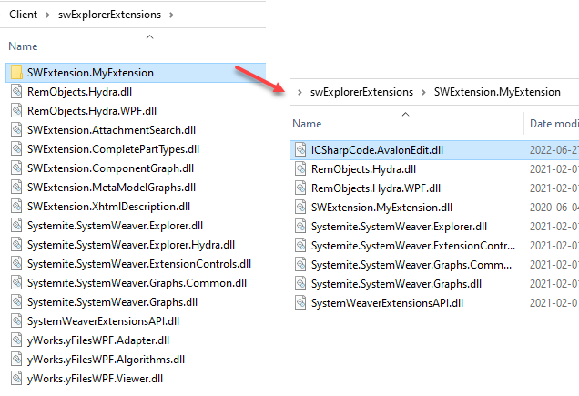 | Improvement | Extensions API | 16445
Script language: Performance analysis elements | Two new scripting elements have been added as tools for performance analysis.  There is a new, optional parameter for <Variable> called logTime. It writes the time it took to calculate the parameter value to the log (Ctrl+Shft+L, 'Info').  Example  <Variable name="currentTARA" select="." as="Item" logTime="true"/>  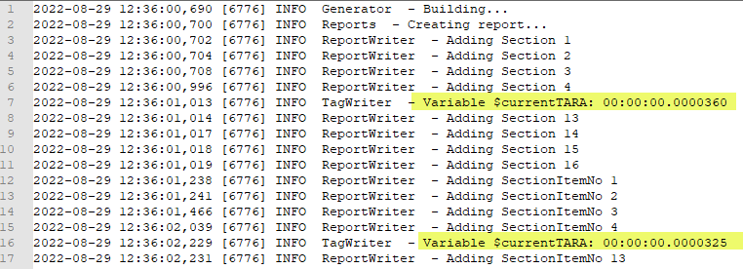  A new Prepare tag prepares the local client cache with items starting at a given start item and following the given part types, much like how the structure tree works. This will load the cache with as few calls to the server as possible.  To determine, if using the Prepare tag with your script is beneficial, i.e., provides performance gains, we recommend reviewing log times and/or other means with and without the statement, to verify that you actually get performance gains. If the data is already in the cache, it should not take a long time to execute, at most 10-100ms.  For details, see the application Help.  Disclaimer: The Prepare statement always forces a call to the server, so it can potentially have a negative effect on performance, similar to when using Axis: back. Due to this, it is advised that <Prepare> not be used unless you are an expert in SystemWeaver Script Language.  Example  <Graph>  <Prepare start="." partTypes="ARSC;ARPP;ARRP" logCaption=" My test log"/>  <Node>  ...  </Node>  </Graph>  Result:  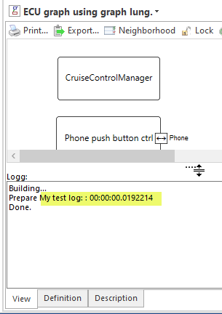 | Improvement | Architect | 16475
API: Minor version update from 1.53.1 to 1.53.2 | The SystemWeaver API has been upgraded from version 1.53.1 to version 1.53.2. Although a minor version upgrade does not technically require that all users receive and utilize the new version of the client applications with the new server, we do recommend it, and it would be needed to obtain the client enhancements and bug fixes listed in the release notes. If you reference them with the specific version flag set to true for inhouse development, you must recompile. | Improvement | API | 16637
Issues view: Loading optimized | The loading of issue views that display issues with references to items has been optimized. | Improvement | User | 16551
Coverage mapping item: support for multi select on left side | The Coverage mapping item view now supports multi-select of items on both the left and right-hand sides, whereas previously, there was no support on the left-hand side.  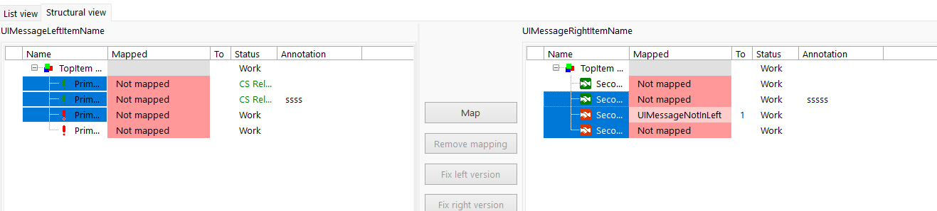 | Improvement | User | 16651
XML Import: Item type included in comparison | The Item type of the Items will now be compared between the incoming file and the existing Items in the database for (repetitive) imports. If there is a mismach of ItemType, there will be a new version created in the receiving end, even if there are no other differences (Changes) in an Item. If an Item is released, there will be a forced new version where the Item type will be updated, and nothing else. | Improvement | Architect | 16462
Home page: Updated embedded web page | The web browser embedded in the Home page has been updated. Links contained in the Home page will now open in the user's default browser app.  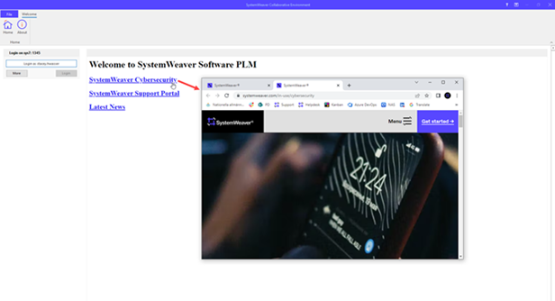 | Improvement | IT Administrator | 16509, 15323
Theme: New look for swExplorer and swArchitect | The theme of the swExplorer and swArchitect client user interfaces (GUI) has been updated to fit our new SystemWeaver color scheme. Additional updates to follow in future releases.  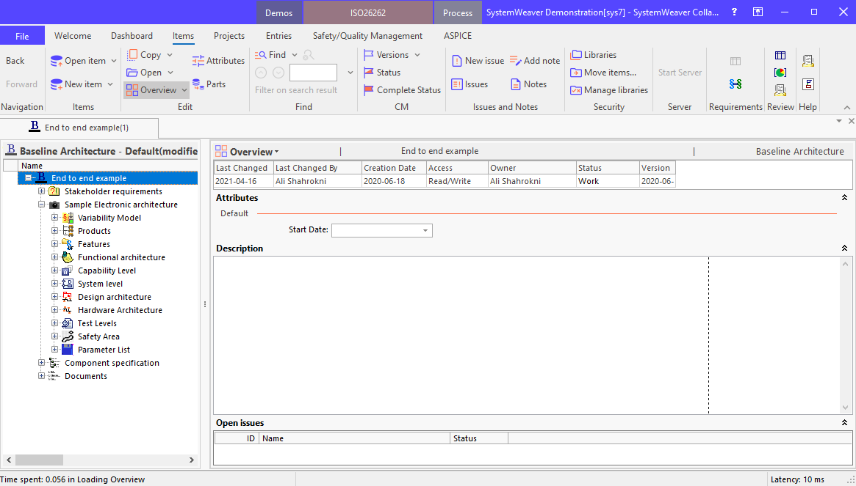 | Improvement | User | 16419
Views: Further implementation of new cancel concept | We continue to replace the green progress bar in the views, with a "Loading..." message and notification banner displaying server call count. The change is now implemented in additional views. The "Loading..." message, along with the notification banner, help to ensure users that their client is still working.  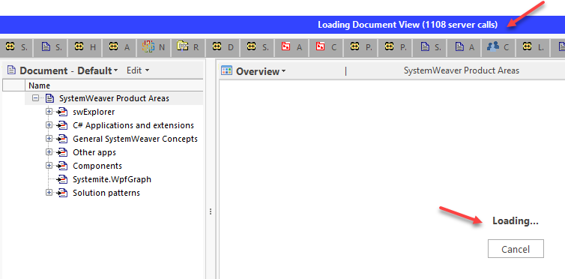 | Improvement | User | 16411, 16545
XML Import: Ignore changes when matched with prefix | In the case of roundtrip imports, i.e., Items included in the import file have their origin in the receiving database, there is now an option called Ignore changes to returning items.  If this option is selected, the comparision between the imported file and existing data in the database will end at the DefObj linking to the Item. All differences between import file and existing data will be ignored for the Items that have the receiving database's prefix in the xID. The only thing that matters is that the ItemType in the import file must be recognizable.  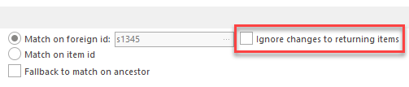 | Improvement | Architect | 16349
Server: Further optimization of general searching | The server has been further optimized for the most common use cases, with respect to serving simultaneous read requests from many users. | Improvement | User | 16636
Server: Updated memory manager | There is a new, optional version of the swDBServer called swDBServerScale. This version is better at handling simultaneous read requests, almost complete parallelization, but at the cost of requiring more memory. Twice as much memory. This is to be considered an alternative to swDBServer if it has been shown in .dlq logs that read performance is a bottleneck. The long-term plan is continued improvement of the swDBServer, but for now swDBServerScale may be considered an alternative. | Improvement | IT Administrator | 16639
Configurable graph: Improvements to layout | The graph will now use the currently displayed layout as a reference point rather than any saved layout when data is modified using the graph right-click menus, or upon a Refresh that results in new/modified data in the graph. Note that some further manual adjustments may be needed to make room for newly added data, e.g., grandchildren. Alternatively, Relayout can be used.  In addition, incremental layout will be used when the graph is not manually editable. | Improvement | User | 16446
ServerMonitorService: Change name of Nlog file | The configuration file for the swServerMonitorService loggins has been renamed from NLog.config to swServerMonitorService.exe.nlog. | Improvement | IT Administrator | 16427
Note: Add Note Description to Grid and Report using DescriptionColumn | It is now possible to add Note Description (text) to Grid and Report using <DescriptionColumn>. It works for both Item and Issue Notes.  Item Notes:  <Grid>  <Options>  <CellAutoHeight/>  </Options>  <Columns>  <DescriptionColumn width="auto" caption="Item Note" rowObject="itemNote"/>  </Columns>  <ForEachNote type="NND">  <RowObject name="itemNote">  <Row/>  </RowObject>  </ForEachNote>  </Grid>  Issue Notes:  <Grid>  <Options>  <CellAutoHeight/>  </Options>  <Columns>  <DescriptionColumn width="auto" caption="Issue Note" rowObject="issueNote"/>  </Columns>  <ForEachIssueInObj type="IR">  <ForEachNote type="NISS">  <RowObject name="issueNote">  <Row/>  </RowObject>  </ForEachNote>  </ForEachIssueInObj>  </Grid> | Improvement | Architect | 16660
Configurable graph: Improved performance manual layout | The performance of manual layout in very large graphs (with many ports) has been improved.  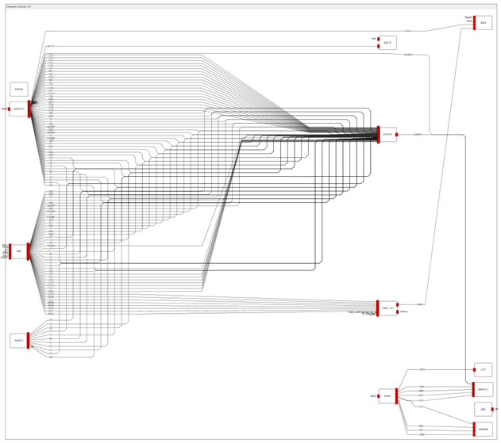 | Bug fix | User | 16585
Icons: New SystemWeaver icons | The new client theme includes new icons for the standard views and ribbon options, as well as for the main SystemWeaver executables.  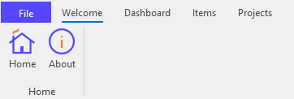  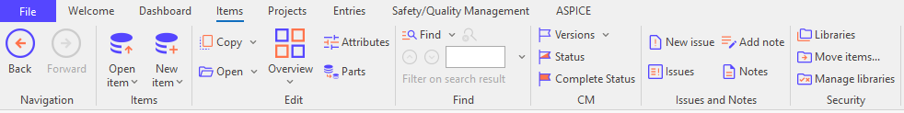  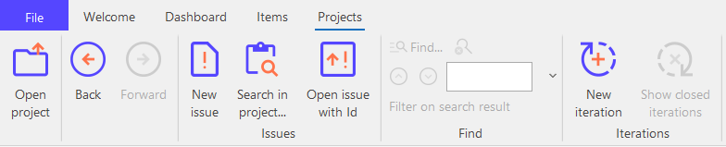  New View icons: New Application (exe) icons: | Improvement | User, IT Administrator | 16470
Server: Initial scheduler implementation | The server has been optimized to distribute high workloads so as to reduce the effect of, e.g., one heavy application on client users. | Improvement | User | 16441
Find: Selecting large set of search results in client closing | The selection of a very large set of search results from a Find operation in the structure tree is now optimized, whereas previously, the client ran out of memory.  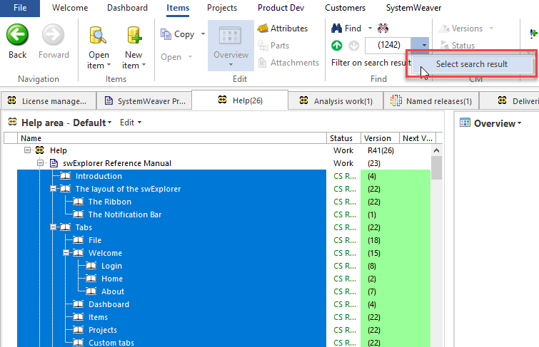 | Bug fix | User | 16401
swAdmin2: maintain sort and previous selection | The swAdmin client now maintains its focus in the Users list when user accounts are sorted, and when an Edit user view is closed.  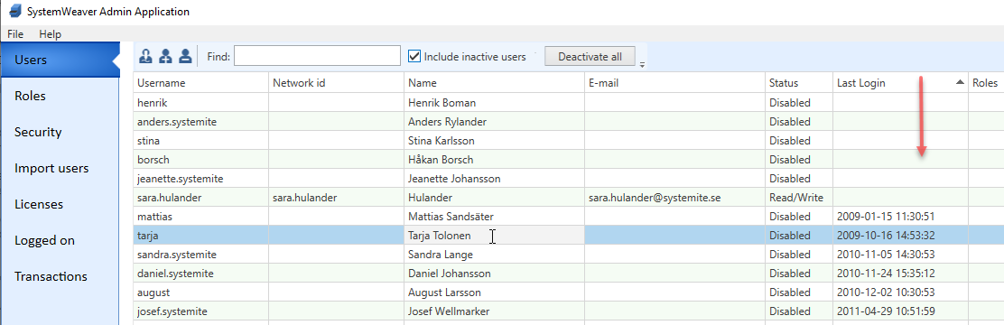 | Improvement | Administrator | 16664
Server: Multiple CallServerConnection is avoided error | This is an error scenario when trying to use short-cuts, or swapping between two uncached tabs before loading completes which is now resolved. | Bug fix | User | 16378, 16556
Configurable graph: Manual layout and edge label issue | This fixes an issue where edge labels where not correctly positioned when moving a node in manual layout mode. | Bug fix | User | 16440
Test Case Manager: Create Test Case throws Assertion failure | This fixes a problem where creating a Test Case when right-clicking in "In Test Case" column threw an error.  In addition, we have fixed a problem with multi-select of items when using either of the Add options in the right-click menu, as well as fixed a problem with deletion of results when navigating between different contexts. | Bug fix | User | 16497, 15545
User type attribute values get cleared upon new version | This fixes a problem where values in Part attributes of type User were getting cleared upon taking out a new version. | Bug fix | User | 16487, 16563
Configurable graph: Bus-labels are shown twice | This fixes an issue where bus labels were sometimes shown twice. | Bug fix | User | 16600
swExplorer: Unable to find vertical pane splitter | This fixes a problem when swExplorer is used over more that one screen, and the tree vertical separator is moved to the second screen, resulting in losing the separator when moving back to using only one screen.  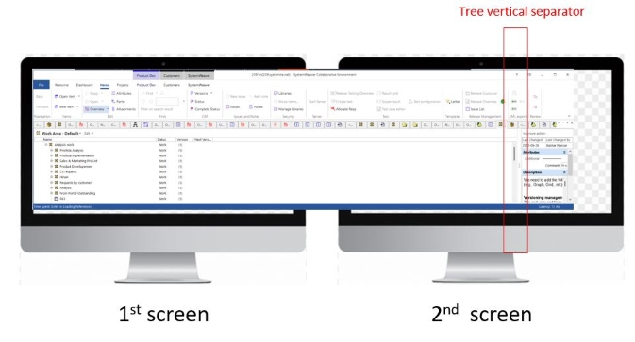 | Bug fix | User | 16675
swExplorer: 64-bit client crashes for some users | This fixes a problem where some users could not use the 64-bit client. | Bug fix | User | 16689
Home page: Unable to load Sharepoint | This fixes an issue with the loading of Sharepoint to the embedded Home page in SystemWeaver.  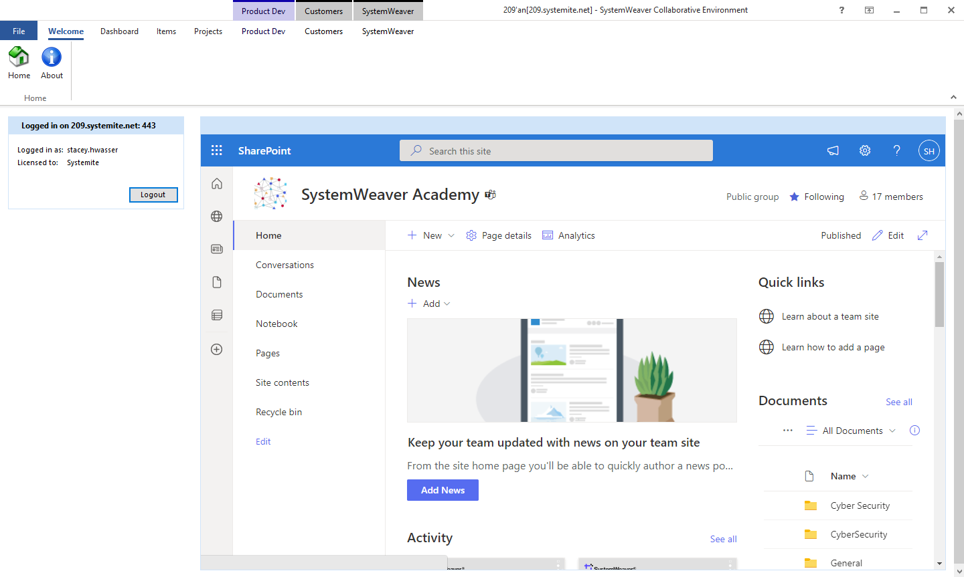 | Bug fix | User | 16490

