Name | Description | Type | User Group | Issue ID
Configurable graph: Tree indication of corresponding object for edge | To improve the usability of the SystemWeaver Graphs view, it is now possible to enable indication (highlighting) in the tree when clicking on the edge of the corresponding object in the graph. To enable the indicator for edge, there are two, new optional attributes called id and objects. More details can be found in the SystemWeaver Script Language Reference Manual in the application Help.  Examples:  <Edge id="id1" objects="."/>  <Edge id="#{? 'x_' +Handle}" objects="/SID1/SID2"/>  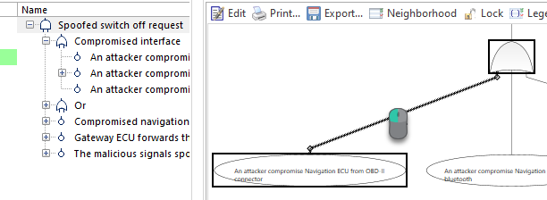 | Improvement | Architect | 14768
Database: Upgrade of database version | The database version identifies the version of the internal database schema used by SystemWeaver. With R39, the version has been updated from 1.43 to 1.44. This is a breaking change.  System Administrators use the swDatabaseManager to update the database version. For instructions, see Updating the Database Version. Be sure to:  - Review the Prerequisites for the update operation outlined in above article.  - Maintain a copy of the database prior to upgrade.  Note: The database upgrade to version 1.44 takes longer than our typical database upgrade.  Approximate run time by database size:  - 3 GB: 5 min  - 36 GB: 1 hr 15 min  If running a mirror server:  - Journaling must be cleared and re-initialized after the database upgrade. The previous .swjournal file cannot be used.  - New mirror .cache files must be created after the database upgrade. The previous .cache file(s) cannot be used.  For SQLite databases only:  Once you have an updated version of the database, we strongly recommend running the Vacuum SQLite database process. For instructions, see Compacting Large SQLite Files. Approximate run time for 35 GB database: 35 min. | Improvement | IT Administrator | 16090
Configurable grid: Improved support for issue attributes | There is a new column type called IssueAttributeColumn that can be used to visualize issue attribute values in a table or grid. Just as with other columns, values can also be modified in the column when used in a grid.  Example:  <IssueAttributeColumn caption="Issue attribute 1" project="SIDP" type="SID1" width="200" readOnly="false" objectName="Issue"/>  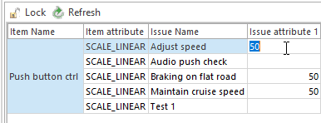  In order to use IssueAttributeColumn in a table or grid, you must first assign a Project SID to the Project containing the attribute.  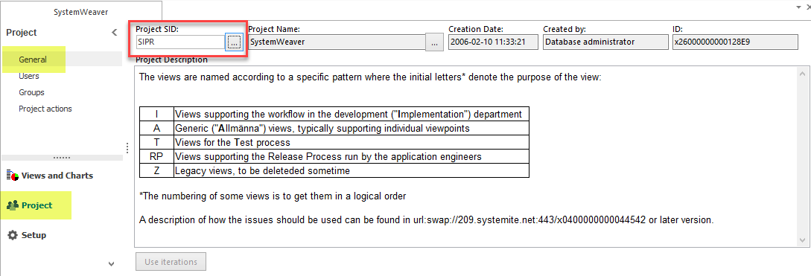 | Improvement | Architect | 16065
Database: Clear journaling via command line | Applicable to our mirror server solution, it is now possible to clear a database's journaling via a command line argument in a script. This is useful if you are performing an automated nightly copyover to a QA environment, where journaling is not needed. It means that you no longer have to use the swDatabaseManager to manually clear journaling.  Example:  swDatabaseManager clearTransactionInfo type="SQLite" name="C:\temp\db.sqlite"  Type Example name value  SQLite C:\MyDatabases\swdb.sqlite  MS SQL Server SYS6|SQLDB-SYSWEAV-PRD  Oracle The TNS alias of the Oracle server. Refer to Oracle documentation for details on TNS.  The operation is the same as using the Clear transaction info (journaling) button in the swDatabaseManager tool.  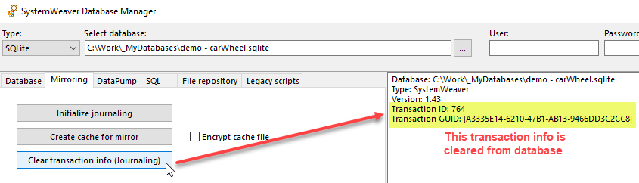 | Improvement | IT Administrator | 16099
Configurable reports and XML: Refresh button | The existing refresh option using the F5 key shortcut is now available as a button in the configurable Report and XML views as well.  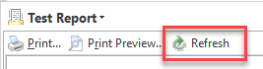 | Improvement | User | 12052
Configurable graph: Improved layout when using port | The graph layout has been improved to render graphs with less edge crossing, better label and port position, etc., This makes SystemWeaver graphs easier to read.  Before  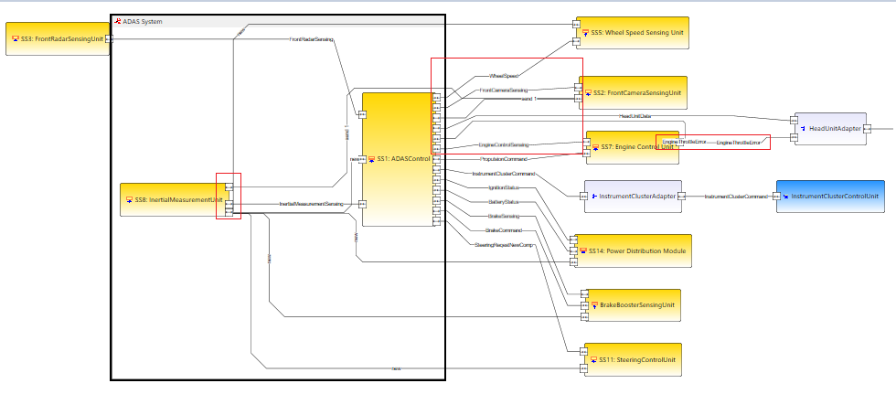  After  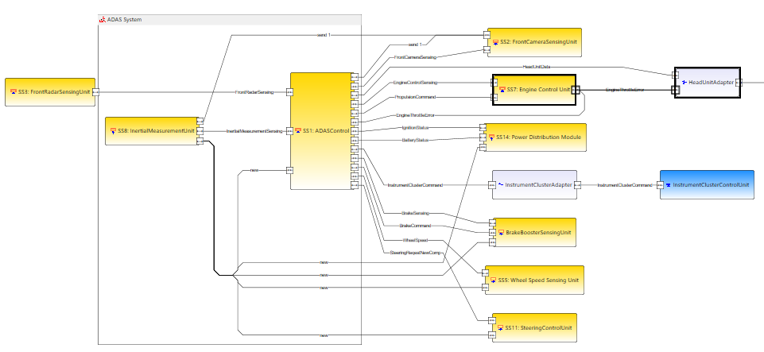 | Improvement | User | 15931
Configurable graph: Support for dummy node | It is now possible to create a node in the Graphs view that does not represent an object (i.e., data) in SystemWeaver. The newly introduced optional attributes id and objects are used for this purpose. More details can be found in the SystemWeaver Script Language Reference Manual in the application Help.  Examples:  <Node id="id-1"/>  <Node id="#{? 'dummy_' + Handle}"/>  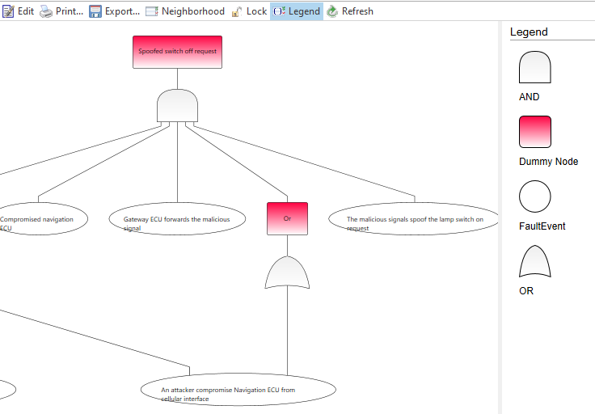 | Improvement | Architect | 14768
MetaModelGraphs: Various enhancements | The MetaModelGraphs extension view has been updated to offer the following:  - Using the new Max children option, you can set the depth (1-6) when including inheritance  - New option to Show default attributes of both item and part types  - Part types pointing to item type "Item" are now shown  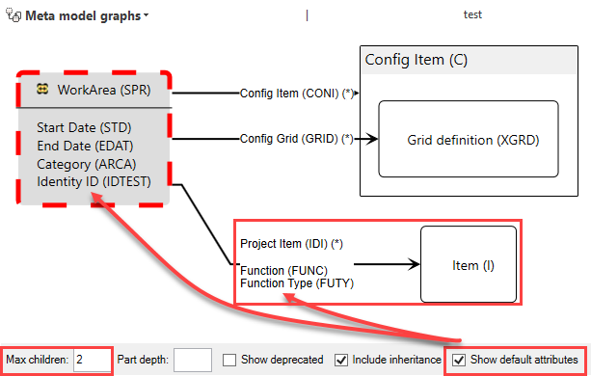 | Improvement | Architect | 15998
FaultTreeGraph: Performance improvement | The loading of large Fault Tree Graphs in the FaultTreeGraph extension view has been optimized.  Example times to load view:  R38 38 seconds  R39 3 seconds  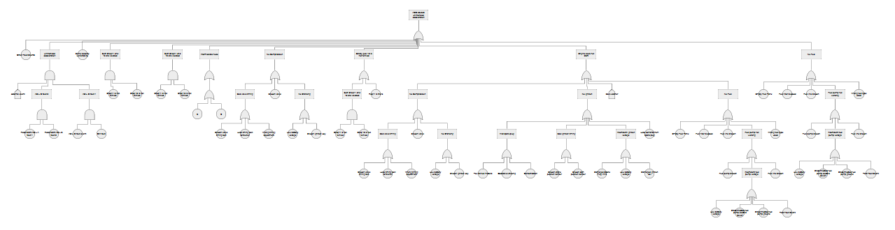 | Improvement | User | 15993
Configurable graph: Support for edge menu configuration | It is now possible to enable the edit functionalities for <Edge/>. This improves the usability of the Edit mode in the configurable Graphs view. The newly supported cases are RemovePart and AddPart.  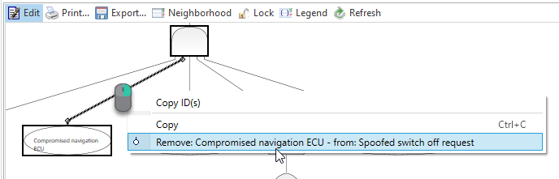  Example:  <Edge from="..." to="...">  <RemovePart part="." caption="Remove #{DefObj} from #{Owner}"/>  <AddPart owner="." partType="SID1"/>  </Edge> | Improvement | Architect | 15835
New version and replace in structure: Change focus to OK button | The focus on the dialog is now on the OK button instead of the Cancel button.  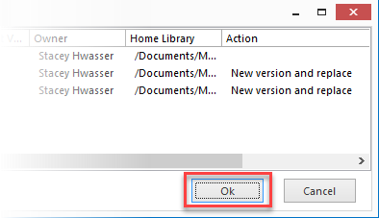 | Improvement | User | 15877
Configurable graph: Support for InOut Port | In the SystemWeaver configurable Graphs view, it is now possible to define an InOutPort, i.e., bi-directional port. An InOut port appears as .  Example:  <Graph>  <ForEach select="/ITFC">  <Node>  <ForEach select="/part::ARRP">  <InPort connection="DefObj"/>  </ForEach>  <ForEach select="/part::ARPP">  <OutPort connection="DefObj"/>  </ForEach>  <ForEach select="/part::ARINO">  <InOutPort connection="DefObj"/>  </ForEach>  </Node>  </ForEach>  </Graph>  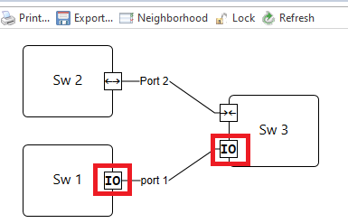 | Improvement | Architect | 15987
XML Export: Various improvements | Additional work has been done in the area of data export to help ensure stability and avoid unnecessary forced new version(s). As a result, there is improved support of database synchronization between SystemWeaver servers. The improvements enable multi-database synchronization as well. At this time, the features listed here apply to XML exports only. In an upcoming release, the improvements described here will also apply to XML imports.  - To synchronize databases, you now set a global prefix for XML exports. This new feature enables you to keep multiple databases in sync. The new option, called Export Import Prefix, is available in the swArchitect client on the Refactorings tab.  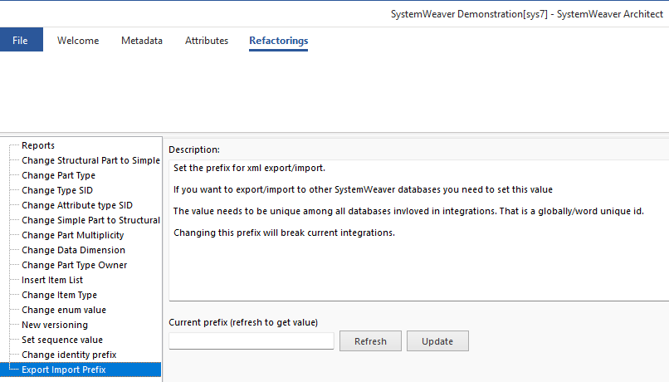  - There are two new XML export configuration tags:  <ValidForeignIdNamespaces>A;B;C<ValidForeignIdNamespaces>  <ExportReferencedMetadataOnly>False</ExportReferencedMetadataOnly>  - Improvements to the standalone swExport application include:  - Supports the use of the same XML Export definition as the XML Export view in the swExplorer.  - Can read the XML Export configuration file. Entering options via command line is still supported.  - Checks and writes to a log file. Errors are written to the log as well.  - If there is any error, the swExport tool will abort the export operation.  - Meta Data Conversion is available now on the export side as well. | Improvement | Architect | 16051, 16082, 16088
API: Minor version update from 1.53.0 to 1.53.1 | The SystemWeaver API has been upgraded from version 1.53.0 to version 1.53.1. Although a minor version upgrade does not technically require that all users receive and utilize the new version of the client applications, we do recommend it and it would be required to access all of the client enhancements and bug fixes listed in the release notes.  Observe that the version number of the API assemblies have been updated, so if you reference them with the specific version flag set to true for inhouse developed extension views, you must recompile. This is a breaking change. | Improvement | API, IT Administrator | 16047, 16045
Configurable grid: Expanded editability | Users can now, not only visualize data in the configurable Grid view, but also design the data directly in the grid. And because it is a generic view, it can be used with all models and use cases in SystemWeaver.  When enabled by a SystemWeaver Architect, users can perform the following actions directly in the grid in accordance with the meta model, in the same way as they can in the structure tree:  - Create new parts  - Add existing parts  - Remove parts  To enable the use of any of the above actions, a SystemWeaver Architect defines Actions and configures which column(s) the action(s) should be available for by using ActionBindings. A right-click menu for the actions is configurable.  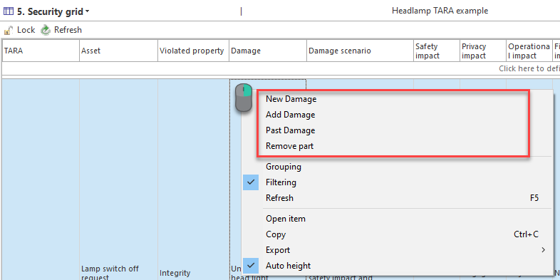  SystemWeaver Architects can view the Grid-specific section of the SystemWeaver Script Language Reference Manual in the Help for more details.  Disclaimer: This new, expanded editability in release R39 is a first version. The configuration format may change in future releases. | Improvement | User | 15866, 15851, 15892, 15928, 15875, 15929, 16103
Configurable graph: Introduction of table layout | It is now possible to define a table layout for the Graphs view using the new GraphTable element. With this enhancement, SystemWeaver offers improved graphical support of many new cases, such as swimlane layout. The newly introduced tags are:  - GraphTable  - GraphColumns  - GraphColumn  - GraphRow  - GraphRows  columnId and rowId are used to define a graph object's (e.g., node) placement in a cell in the GraphTable. More details can be found in the SystemWeaver Script Language Reference Manual in the application Help.  Example:  <Graph>  <GraphTable id="id_1" caption="#{? Name + Version}">  <GraphColumns>  <ForEach select="/10IPR">  <GraphColumn id="C_#{Handle}" caption="#{Name}"/>  </ForEach>  </GraphColumns>  <GraphRows>  <ForEach select="/10IPR/10IFE/10IFP">  <GraphRow id="R_#{Handle}" caption="#{Name}"/>  </ForEach>  </GraphRows>  </GraphTable>  <ForEach select="/10IPR">  <Variable name="columnId" as="String" select="'C_' + Handle"/>  <ForEach select="/10IFE">  <Variable name="rowId" as="String" select="/10IFP.Select('R_' + Handle).Join('')"/>  <Node columnId="#{? $columnId}" rowId="#{? $rowId}"/>  </ForEach>  </ForEach>  </Graph>  Result:  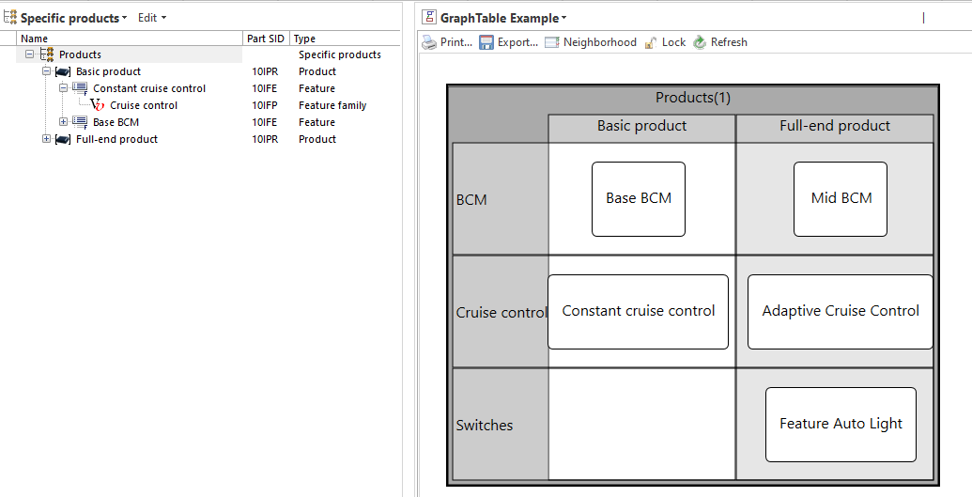 | Improvement | Architect | 15840, 15927, 15901
Validity check: Introduction of new feature | Release R39 introduces an improved way of running a consistency check on large data using a new Validity check feature which is fully configurable, and displays together with any view. To activate the Validity check feature, select it in the Overview drop-down menu.  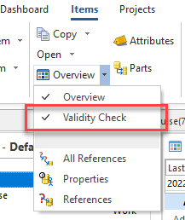  Note: The feature must be configured for use.  When activated by a user, the view appears in a pane below the currently loaded view, as shown in the example below. The view can be deactivated be unselecting the option in the same drop-down menu.  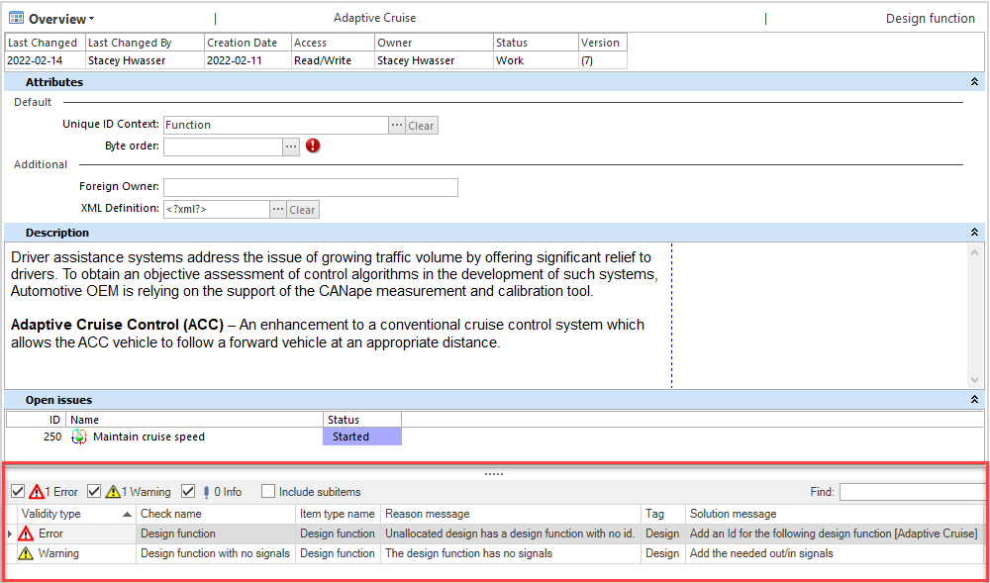  Main features:  - Activate and view simultaneously with other views  - A way to centrally define validity checks  - Full support for the SystemWeaver Path Query Language  - Configurable validity check severity, e.g., Error, Warning, Info, Message, etc.  - Configurable validity check type, reason for check, solution message, etc.  - Checks are applied to item types, with inheritance supported  - Selections in the view are indicated in structure tree  - Compatible with the use of the Secondary item view for improved work efficiency  Warning: When including sub-items in the view, be aware that the check is then run on the entire sub-structure as well. | New | User | 16073, 16085, 16012, 16104, 15913, 15922, 16007, 15921
Sequence Diagram: Improved layout | The following improvements have been made to the Sequence diagram:  - Improved support for gate and endpoint when having multiple messages  - Support for frame inside fragment as a sub-node to enable editability, and offers better styling  - Improved support for sub-sequence diagram  - Improved message placement when the caption for a lifeline is long  - Several improvements to the layout and graph object positioning  Known issue: The Neighborhood pane is currently not showing complete information [16083] | Improvement | User | 15861
Excel Import: Enhancements to ExcelImport tool | The SystemWeaver.ExcelImport tool now supports a basic import of both items and their parts, i.e., hierarchical import. Although not part of our core product, it can be used to import data from MS Excel.  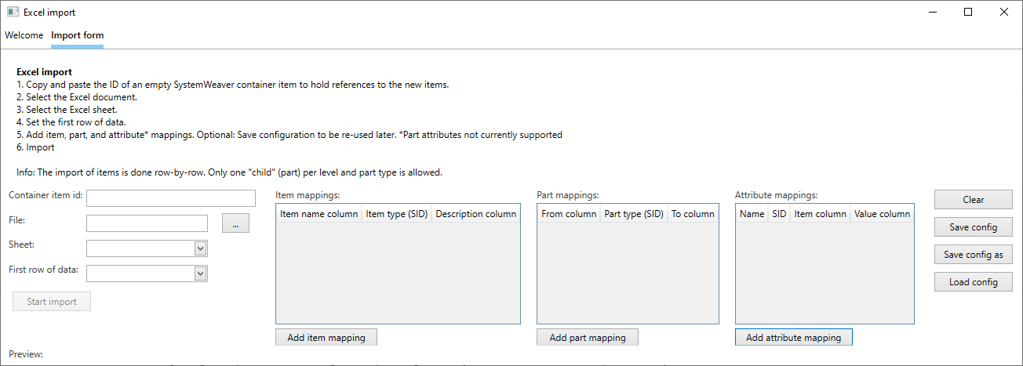  The new version enables the import of one "child" (part) per level and part type, and no limit on the number of levels, i.e., the depth.  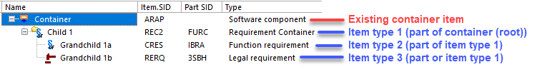  For more information, see Using the Excel Importer. | Improvement | Architect | 15885, 15853, 15873
Server: Support for TLS v 1.2 | The SystemWeaver server application now supports TLS 1.2. With version R39, the server machine must have .NET Framework version 4.7 or later installed. This is a breaking change. | Improvement | IT Administrator | 15121
Server: Optimized filtered search execution time | The search execution time has been optimized for a number of simple, filtered searches.  General Search Example:  R38 R39  ItemAttributeCompare <Filter><ItemAttributeCompare sid="TEST" value="CT.00"/></Filter> 10.31 sec 0.68 sec | Improvement | User | 15900, 15906, 15915, 15904, 15898
Configurable graph: Improved node shape ratio in legend | The ratio of node shapes in the configurable Graphs view Legend has been improved.  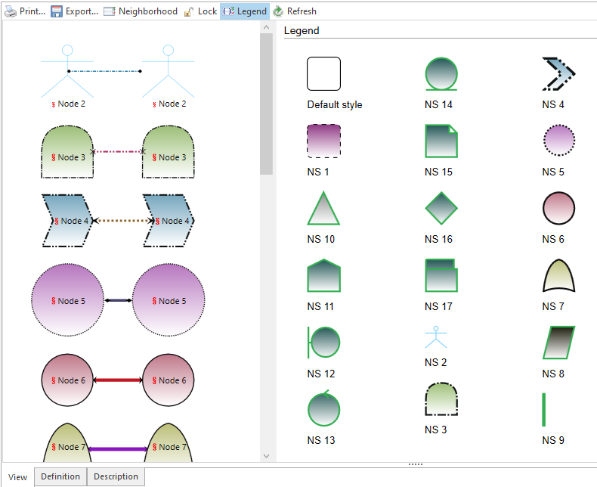 | Improvement | User | 15849
CreateTestPlan: Include part attributes | The CreateTestPlan extension view now supports the inclusion of part attributes in the Test plan. This is defined using a new PartAttributesToCopy tag.  <CreateTestPlanConfig id="1">  ...  <PartAttributesToCopy>  <Attribute partType="ITTR" attributeType="ABAN"/>  <Attribute partType="ITTR" attributeType="ABA2"/>  </PartAttributesToCopy>  ...  </CreateTestPlanConfig> | Improvement | Architect | 15992
Configurable grid: New options for column header orientation and alignment | There is now an option in the configurable Grid view to enable setting the orientation of the column header as a given angle. For example, "90" results in the vertical orientation of the column header. Supported values are integers between 0-90. Rotated headers can make it much easier for users to view a large number of narrow columns, e.g., with consistency checks, without needing to scroll horizontally in the grid.  The rotation configuration can apply to an entire grid using the new <ColumnHeader> option, or to an individual column using the new columnHeaderAngle attribute.  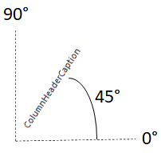  Example:  <Options>  <ColumnHeader angle="90"/>  </Options>  Result:  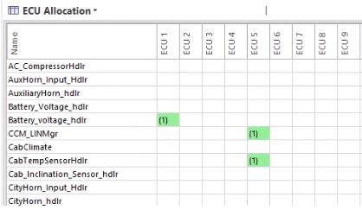  Example:  <Columns>  <ItemNameColumn caption="Reused Item Name"/>  <ItemVersionColumn/>  <ItemNameColumn caption="Part Name" columnHeaderAngle="90"/>  <TextColumn caption="Part Owner" columnHeaderAngle="90">#{? Owner}</TextColumn>  <TextColumn caption="Number of reuse" columnHeaderAngle="90">#{? .}</TextColumn>  </Columns>  Result:  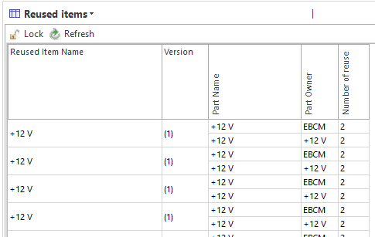 | Improvement | Architect | 15879, 15852, 15845, 15881
Version view: Error upon Compare XML Definition | This resolves an error thrown when attempting to use the Compare XML Definition feature for XML attributes in the Versions view. | Bug fix | User | 16001
Autosar Datatype editor: Problem with Max value | This fixes an issue when using a Max value combined with a negative offset, where the resulting value was not 0. | Bug fix | User | 16011
Secondary item view: Extensions throw EInvalidOperation error | This fixes an issue where some extension views opened in the Secondary Item view threw an error. | Bug fix | User | 15715
MultiInstance VS template: Remove GetGroup | The GetGroup method has been removed, as it is not used and caused confusion.  To define a group for a multi-instance view, you use the ViewSettings tag.  Example:  <ViewSettings>  <Caption>Function realization</Caption>  <RibbonGroup>Design</RibbonGroup>  <Description>Hint shown in the ribbon</Description>  <Image typeImage="25"/>  </ViewSettings> | Bug fix | Extensions API | 15995
Configurable graph: Fix the label size for some shapes | This fixes an issue with the size of the bottom-positioned caption width for some shapes. Captions that are longer than the max display size, will now be truncated with "...". A tooltip is provided when hovering over the object to allow viewing of the entire caption. | Improvement | User | 15882, 15850
Domain allocation: Assertion failure thrown with Clear button | This resolves an assertion failure thrown removing a Bus Topology from a Domain Allocation using the Clear button. | Bug fix | User | 15857
Component graph: Make Function level interface optional | This fix now enables the graph to be used when the Function level does not have InPort and OutPort. The Function level interface is now optional. | Bug fix | Architect | 15905
Coverage matrix: Various bug fixes | The following bug fixes were completed in the HazardIdentification.CoverageMatrix extension view:  - Fix an exception thrown when when the mapping item does not have an icon assigned  - Re-introduce auto-sizing of text boxes in the Edit dialog.  - Fix an issue with the display of text attributes in the Edit dialog. | Bug fix | User | 16063, 15891, 15608

