Name | Description | Type | User Group | Issue ID
swAdmin2: Introduction of API transaction statistics | The swAdmin2 tool now includes a first version of an API transactions display which will provide administrators with statistics on API usage per license.  - View total transactions data  - View daily transactions data  - Filter by preset or custom time period  - Refresh data for current time period  - Export 2 years of transactions data  More details to follow in future releases.  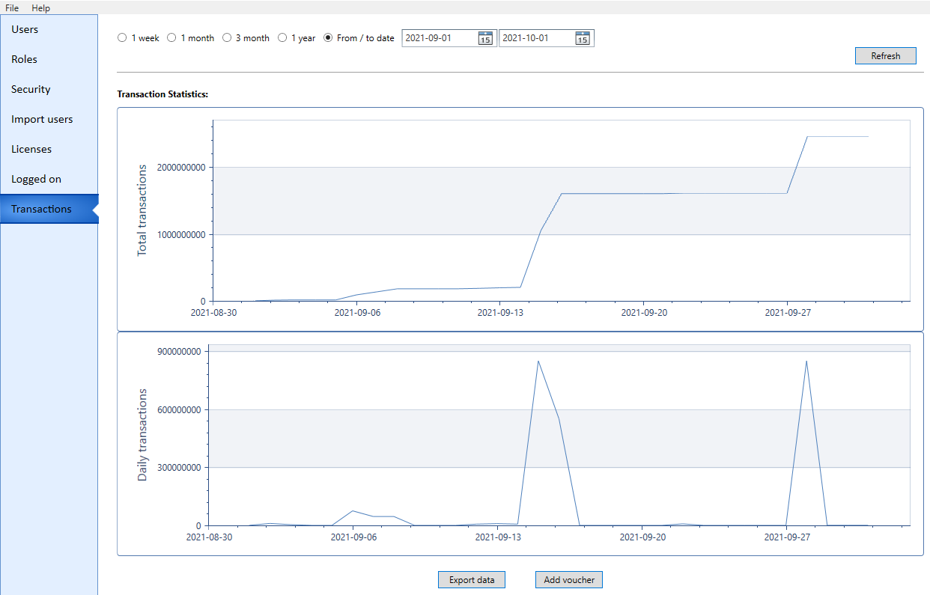 | New | Administrators | 15275, 15763
swAdmin2: Introduction of license assignment | With the R38 release, all users must be assigned to a license. There are two use cases - automatic assignment to a Default license, or manually specify license assignment. Instructions will be included in your upgrade package.  Automatic assignment  The most common scenario is an installation with one license file identified as the Default license. This will work in the same way as it has before.  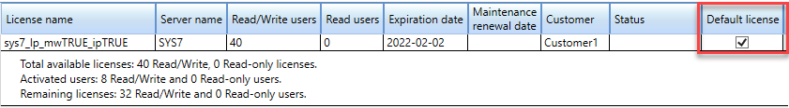  With automatic assignment, users are automatically assigned to the default license. No additional action is needed. If multiple license keys are used, one can be designated as the default. At any time, an Administrator can change the Default designation from one license to another, and/or assign specific users to any specific license.  Manual assignment  For installations with multiple licenses and/or where no default license will be designated, Administrators have the option to manually handle user license assignment, In this case, assignment can be done for a single user via the Users tab.:  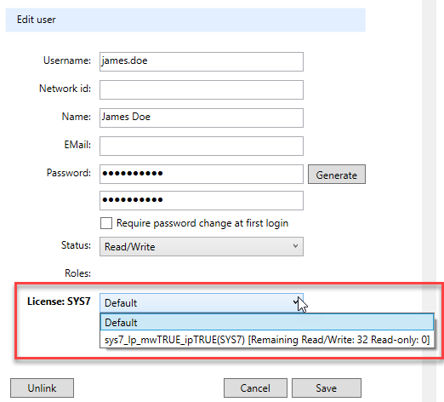  Or, alternatively, as a batch assign operation via the Licenses tab.  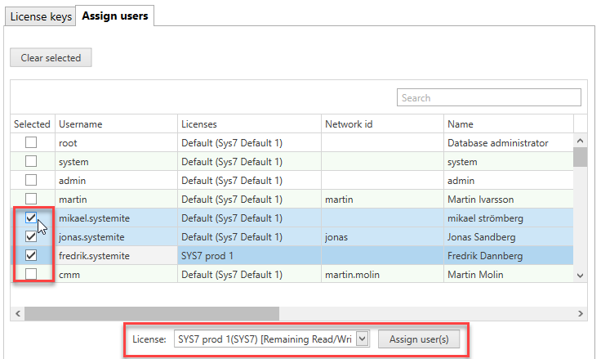  When upgrading to R38 given this use case, initial assignment must be made for all existing users.  This will not need to be done for future upgrades for existing licenses.  It is important to note that if an assignment is not made for a user, and no license is designated as the Default, the user will not be able to log in until they are assigned to an available license. | New | Administrators | 15547, 15560, 15580, 15562, 15766
swAdmin2: Restricting capabilities | It is now possible for Administrators to use the swAdmin2 tool and the Path Query Language to restrict any of the following standard capabilities (actions) in the swExplorer client.  - Printing documents  - Downloading documents  - Copying document content  - Printing reports  - Downloading reports  - Copying report content  - Exporting XML  - Copying XML content  - Exporting grids to Excel  For more information, see https://support.systemweaver.se/en/support/solutions/articles/31000153310-restricting-capabilities.  Note: Although a first version has been available in earlier releases for evaluation purposes, we are officially introducing the feature now. | New | Administrators | 15792
swAdmin2: Capture creation date for user accounts | The creation date of user accounts is now captured and displayed for accounts created using release R38 or later. Accounts created prior to release R38 will display a null value.  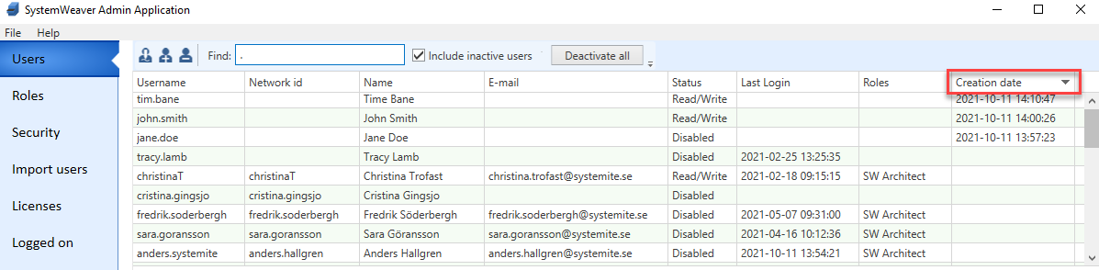 | Improvement | Administrators | 15705, 15571
swAdmin2: Display of additional license key information | Release R38 includes a new license format. Upgrades will require replacing existing licenses. This is a breaking change.  The Licenses tab now clearly displays the following additional information for each uploaded license key file:  - License name  - Server name  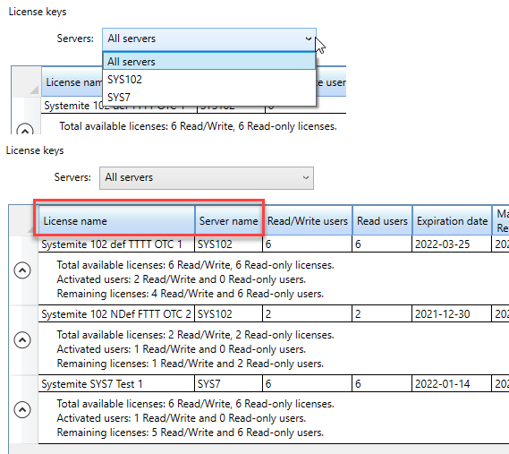  Note: The Servers drop-down field is only applicable when licenses valid for different servers are uploaded. | Improvement | Administrators | 15716, 15807, 15547, 15793, 15774, 15782, 15783, 15796, 15629
Projects: Removal of Transitions pane | The Transitions pane in Project Workflow has been removed. Transitions were replaced with Workflow configuration with the R25 release, but remained in the client for reference to old transitions during a transition period. Should you still want to refer to previously used Transitions, be sure to document them in some manner prior to upgrading. | Improvement | Administrators | 15472
swAdmin2: Account created with existing Network id | When trying to create an account with a Network id that is already in use, you will now get a "User with Network id: user already exists." message when clicking Create, and the new account will not get created. | Bug fix | Administrators | 15309
API: Broker.FindUserWithForeignId | The following methods have been added to the API.  Broker.FindUserWithForeignId  Returns user with given foreign id, or null if user with that name does not exist. If for some reason, there exists several users with the same foreign id, this methods returns null.  Broker.HasUserWithForeignId  Returns if a user with foreign id exists. If for some reason, there are several users with the same foreign id this method returns true.  Refer to the R38 version of SystemWeaverClientAPI.XML for more information. | Improvement | API | 15444
API: Optimized search for items with attribute value | A common use case when writing api programs and extensions is searching for items with a given attribute value, for example, get all requirements with a given requirement id. This is traditionally done by creating a filter and calling IswQ. Due to performance reasonS, we have added a specific call on IswQ to do this:  IswItems GetItemsWithAttributeValue(IswItemType itemType, bool includeSubTypes,  IswAttributeType attributeType, string attributeValue);  This call should be significantly faster (e.g., up to 80%) and put lower load on the server than using filters.  It can be used for attributes which can be expressed as a string, e.g., string and integer. | Improvement | API, Extensions API | 15775
API: Upgrade from 1.52.1 to 1.53.0 | The SystemWeaver API has been upgraded from version 1.52.1 to version 1.53.0. This will require that all users receive and utilize the R38 version of the client applications (swExplorer, swAdmin2, swArchitect). In addition, this requires that any API applications developed in-house be recompiled with the newer version SystemWeaverClientAPI.dll. This is a breaking change. | Improvement | API, IT Administrator | 15816
Configurable graph: Support for graph node custom size | It is now possible to control the size of all node shapes, as well as the size of a node caption.  This new custom size option is available for the following node shapes:  - <Actor/>  - <AndGate/>  - <Chevron/>  - <Ellipse/>  - <OrGate/>  - <Parallelogram/>  - <Rectangle/>  - <RectangularPentagon/>  - <Triangle/>  - <Circle>  - <Boundary/>  - <Control/>  - <Note/>  - <Diamond/>  - <Package/>  Example  <AndGate width="" height="" minWidth="" maxWidth="" minHeight="" maxHeight=""/>  <Circle diameter="" minDiameter="" maxDiameter=""/> | Improvement | Architects | 10825, 15526
Icons: New type icons | The following new Type icons have been added. They can be used as image icons for item, part, and issue types, as well as for multi-instance configurable views, and plugins:  # Icon Name Intended use  568 Aeroplane General system modeling  569 Attack Event Cybersecurity  570 Attack Vector Cybersecurity  571 Audi Organization specific  572 BMW Organization specific  573 Cybersecurity Area Cybersecurity  574 Cybersecurity Catalog Cybersecurity  575 Design Constraint Container Requirements management  576 EFeature Container Requirements management  577 Expected Feature Container Requirements management  578 Generic Threat Cybersecurity  579 Koenigsegg Organization specific  580 Mercedes Organization specific  581 Non Threat Cybersecurity  582 Process Collection General process modeling  583 Requirement Container - Orange Requirements management  584 Requirements Container - Black Requirements management  585 Requirements Container - Blue Requirements management  586 Requirements Container - Gray Requirements management  587 Requirements Container - Green Requirements management  588 Roles General process modeling  589 Security Property Catalog Cybersecurity (identical to 574 - to be modified for R39)  590 Threats Catalog Cybersecurity  591 Type of Threat Cybersecurity  592 Volkswagen Organization specific  593 Vulnerability attack Cybersecurity  594 Zenseact Organization specific | Improvement | Architects | 15767
Configurable graph: RemovePart support for list | For editing in the configurable graph view, the <RemovePart part=".." caption=”…”/> tag now supports list of part in the attribute part=”..”.  Example  <RemovePart part="Context:/back-to-part::Req" caption="..."/> | Improvement | Architects | 15036
Configurable graph: Support for configuring sub-menu using "...(->)...(->)..." | There is now support for configuring the sub-menu using "...(->)...(->)..." in the caption attribute for <AddPart/> and <RemovePart/>.  Example  <RemovePart part="Context:/back-to-part::ReqSection" caption="Menu X (->) Menu X.1 (->) Menu X.1.1 (->)Remove Req from Section #{Owner.Name}"/>  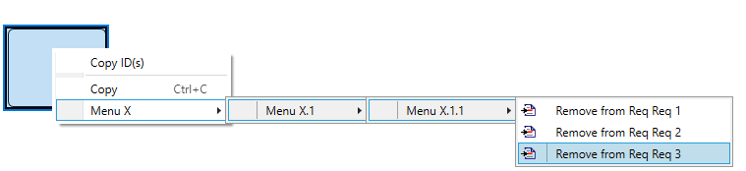 | Improvement | Architects | 15616
Component graph: Support for multiple signal types | The Component graph extension now supports different signal item types and part types. There is a new attribute for the <Signal> tag called itemSids. For multiple signal types, you would use this attribute instead of itemSid to list the SIDs separated by a semi-colon.  Also, there is a new attribute for the <InPort> and <OutPort> tags called partSids. For multiple signal part types, you would use this attribute instead of partSid to list the SIDs separated by a semi-colon.  Note: For backward compatibility, the itemSid and partSid attributes can still be used when only one signal type exists. However, itemSid and itemSids cannot be used together, and partSid and partSids cannot be used together.  Examples  <ComponentGraphConfig>  ....  <Function itemSid="BIDA">  <InPort partSid="IREC"/>  <OutPort partSid="ISEN"/>  </Function>  ....  <Signal itemSid="ARSI"/>  ....  <Components>  <Component itemSid="ARAP" partSid="ITFC">  <InPort partSid="ARRP"/>  <OutPort partSid="ARPP"/>  </Component>  </Components>  ....  </ComponentGraphConfig>  <ComponentGraphConfig>  ...  <Function itemSid="BIDA">  <InPort partSids="IREC;IREC1"/>  <OutPort partSids="ISEN;ISEN1"/>  </Function>  ....  <Signal itemSids="ARSI;ARSI1;.."/>  ....  <Components>  <Component itemSid="ARAP" partSid="ITFC">  <InPort partSids="ARRP;ARRP1"/>  <OutPort partSids="ARPP;ARPP1"/>  </Component>  </Components>  ....  </ComponentGraphConfig>  For multiple signal types, the swExplorer will present the user with a menu that includes all the possible signals according to the configuration, as shown below.  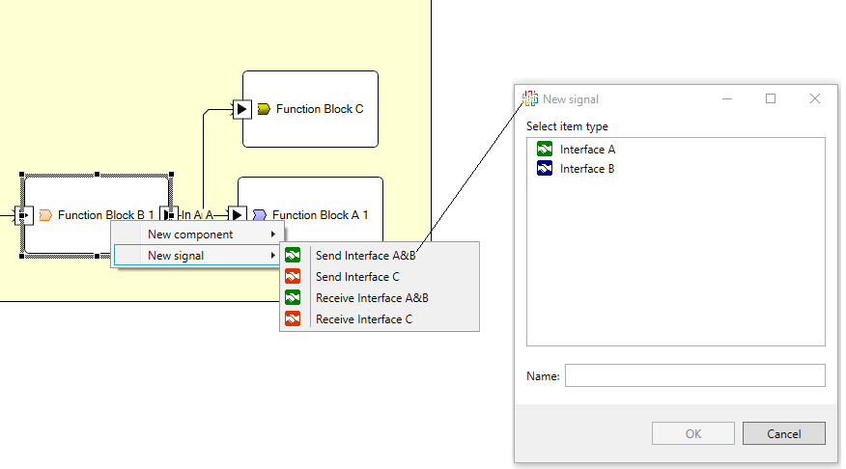 | Improvement | Architects | 14910
Configurable graph: Enable caption in <AddPart> | There is now support for configuring the caption of the <AddPart/> tag. The caption can be a String or PathQuery.  Example:  <AddPart owner="..." partType=".." caption="#{PathQuery}"/> | Improvement | Architects | 15622
Configurable graph: Support for multiple distinct mapping per pair in MappingItem | An optional multipleDistinctMappingPerPair attribute determines if multiple mapping between the same pair of items is allowed. A "true" value enables multiple mapping items for the same pair of items. A "false" value enforces only one mapping item per pair of items. The default is "false". Note that the multipleDistinctMappingPerPair can only be used when distinctMappingPerPair="true".  <Graph>  <Mappings>  <MappingItem id="" leftCaption="..." rightCaption=".." distinctMappingPerPair="true" multipleDistinctMappingPerPair="true">  ......  </MappingItem>  <Mappings>  ...  </Graph> | Improvement | Architects
Configurable graph: Support for new node shapes | Additional node shapes have been added.  Name Tag Shape  Boundary <Shape> <Boundary width="50" height="100"/> </Shape>  Control <Shape> <Control width="50" height="100"/> </Shape>  Entity <Shape> <Entity width="50" height="100"/> </Shape>  Note <Shape> <Note minWidth="20" maxWidth="200" minHeight="40" maxHeight="200"/> </Shape>  Diamond <Shape> <Diamond minWidth="20" maxWidth="200" minHeight="40" maxHeight="200"/> </Shape>  Package <Shape> <Package minWidth="20" maxWidth="200" minHeight="40" maxHeight="200"/> </Shape> | Improvement | Architects | 15710
Configurable graph: Improved menu activation for parts | The activation of the context menu options for Add, New and Paste as is fixed to handle cases where different part types have different owners.  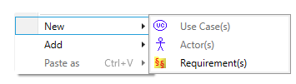 | Bug fix | Architects | 15512
Sequence diagram: Introduction of visualization and editing | Visualization  There is now a first version of a sequence diagram visualization using the built-in configurable graph view. The sequence diagram supports the following:  - Lifeline of different types (Actor, Object,Boundary, Control, and Entity)  - Messages  - Gate  - EndPoint  - Fragment of different types (Alternative, Optional, Parallel, Loop, Critical region, Negative, Sequence diagram,..etc)  - Frame  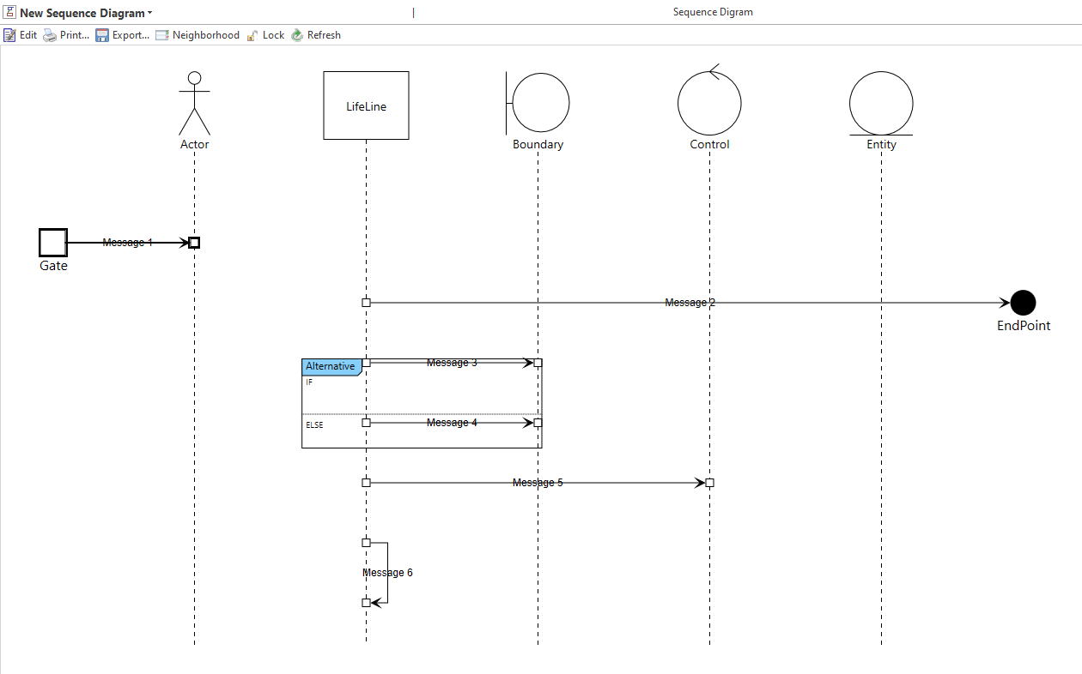  Edit Mode  In addition to using the built-in configurable graph to view a sequence diagram, it is now possible to edit the sequence diagram directly in the view. With this first version of editability, you can perform the following:  - Add/New/Remove all sequence diagram objects:  - Any type of LifeLine  - Any type of Fragments  - Frame  - EndPoint  - Gate  - Connect different sequence diagram objects using messages:  - Gate -> LifeLine  - LifeLine-> LifeLine  - LifeLine-> EndPoint  - Self message  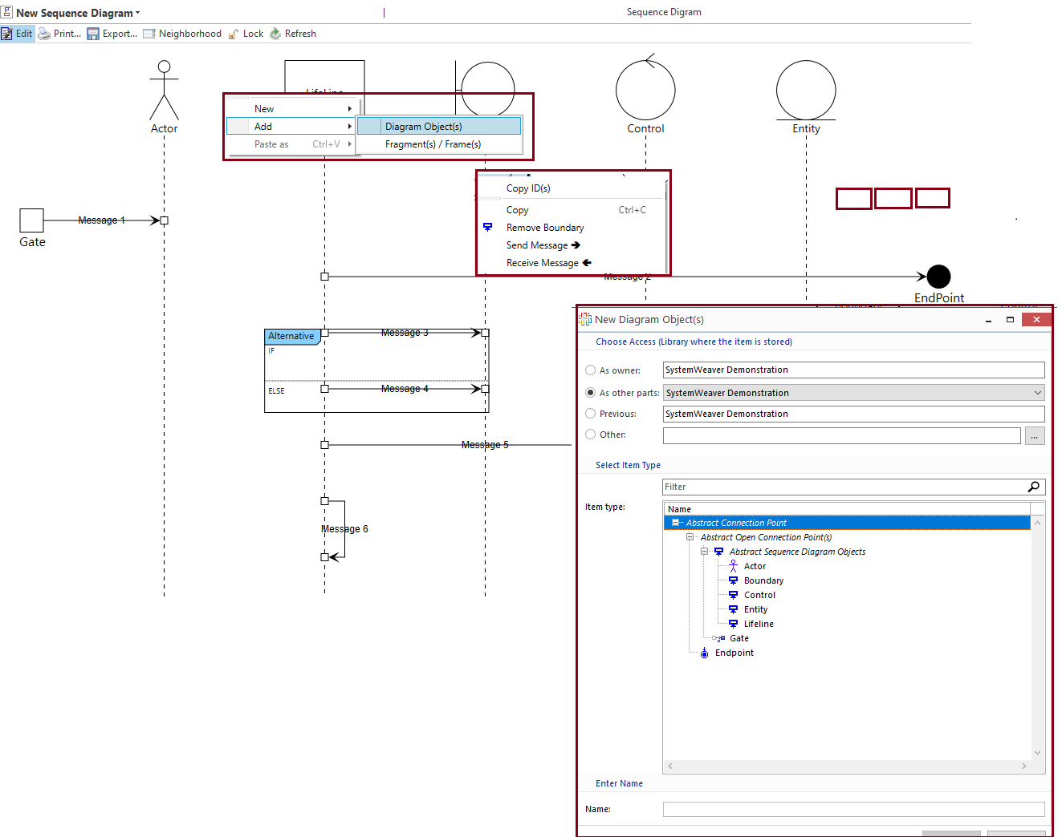 | New | Architects, User | 15602, 15764, 15762, 15605, 15703, 15603, 15771, 15787, 15710, 15704, 15604, 15607, 15757
Extensions API: Updated VS templates | The SystemWeaver Visual Studio templates have been updated. When creating new extensions, use the new versions which can be downloaded from the support portal. | Improvement | Extensions API | 15799
Database: Upgrade of database version | The database version identifies the version of the internal database schema used by SystemWeaver. With R38, the version has been upgraded from 1.42 to 1.43. This is a breaking change.  System Administrators use the swDatabaseManager to update the database version. See https://support.systemweaver.se/en/support/solutions/articles/31000161969-updating-the-database-version.  - Review the Prerequisites for the update operation outlined in above article  - The database update operation takes about 1 min.  - Maintain a copy of the original database  - If you need to restart the Update operation, close the application in between update attempts.  - If running a mirror server:  - Journaling must be cleared and re-initialized. Previous .swjournal file cannot be used.  - New mirror .cache files must be created. Previous .cache files cannot be used.  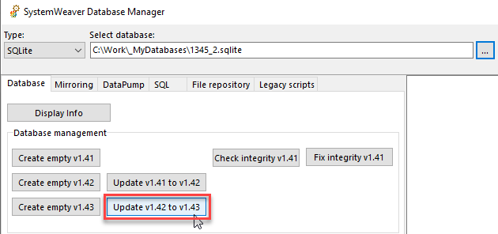 | Improvement | IT Administrator | 15711, 15577, 15606, 15706, 15579, 15571, 15578, 15576, 15700
Coverage (Mapping Item): Add possibility for fix version buttons to take out new version | This fixes an issue where if the mapping item was in a CS_Released status it was not possible to update the version of the right or left hand side of the mapping item in the view. | Bug fix | Users | 15804
New version and replace: Basic support for recursive operation | There is now basic support for performing New version and replace recursively in the structure tree.  The option will now display as New version and replace in structure.  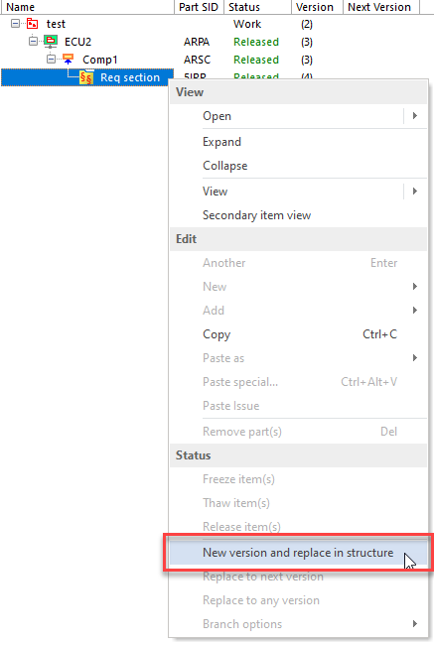  As before, the option creates a new version of the selected part's item and replaces the item with the new version.  Now, it will also do the same for any part items located above the selected item as long as:  - You have access right to the item, and  - There are no later versions of the item  A dialog will indicate the Action for each part's item. If one or both of the above two criteria are not true, the New version and replace in structure operation will not be performed.  In the below example, the user has write access to all items in the structure above the selected item, and there are no existing newer versions. The replace operation will be performed on each of them as shown below.  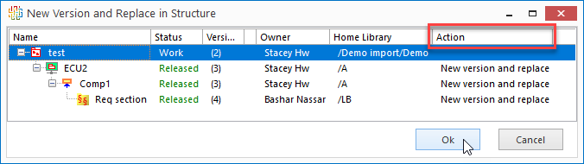  If, at any point, an item or sub-structure does not meet the above criteria, the dialog will display this and perform no actions. In the below example, the user does not have access to "ECU2" and, therefore, cannot take out a new version on it or its sub-structure.  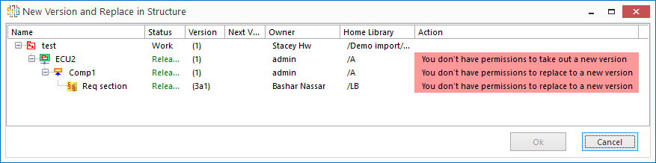  The user can then investigate the case to determine how to proceed. | Improvement | Users | 15619, 11292
Performance: Optimized new version and replace | The New version and replace operation has been optimized. Depending on the selected structure, operation time is now up to 100% faster.  Examples  In seconds  No. of items in selected structure R37 R38  15,266 30 < 1  2,041 11 < 1 | Improvement | Users | 15456, 15711
Extensions API: Improved Hydra exception message | We have improved how exceptions thrown in an extension are displayed. For example, a stack trace will be shown, if possible.  To support this, we added a method to the IswExtensionInfo interface. For the improved exception message to apply to existing extensions, the extensions must be manually updated with ExtensionInfo inheriting from ExtensionInfoBase:  public class ExtensionInfo : ExtensionInfoBase, IswExtensionInfo | Improvement | Extensions API | 9610
Performance: Optimized loading of structural parts | With R37, we optimized the loading of structures with simple parts. In R38, we have taken the first step to optimize the loading of structures containing structural parts, e.g., such as Test structures and views with lots of nodes. Further improvements to this are planned for later releases. The improvement times will differ depending on the number of structural parts, etc.. Below are a two small examples.  In seconds  R37 R38  Load Scope result view for Test suite structure, 815 items 47.31 10.35  Load Test suite structure, 1,011 items 4.73 3.35 | Improvement | Users | 15416
Signature: Clarify when digital signature attribute is available | Signature attributes will now be grayed-out when an item is not in "CS_Released" status to more clearly identify that the attribute cannot be used with other item statuses.  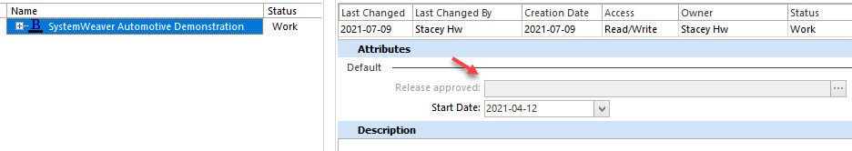 | Improvement | Users | 15467
Clone item: New clone to clipboard option | Whereas previously the Clone item view offered an option to Clone that opened the clone in a new tab, with R38 it now also provides an option to Clone to clipboard. The first version of this new option enables you to clone, e.g., a sub-structure, to your clipboard and remain in the item tree where you can then paste (Ctrl-V) the clone.  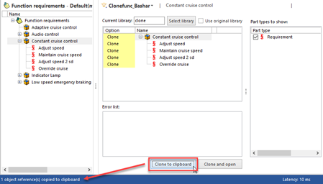  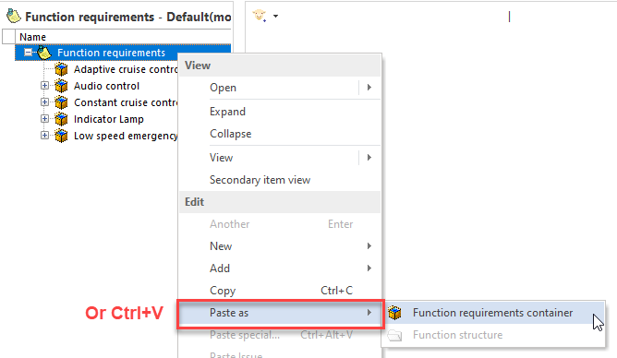 | Improvement | Users | 15733
Configurable graph: Support for icon in the configurable menu | The sub-menu in the configurable graph now shows the part type icon. | Improvement | Users
DataTypeEditor: Support for BITFIELD_TEXTABLE | The Data type editor now supports the compu method category BITFIELD_TEXTABLE:  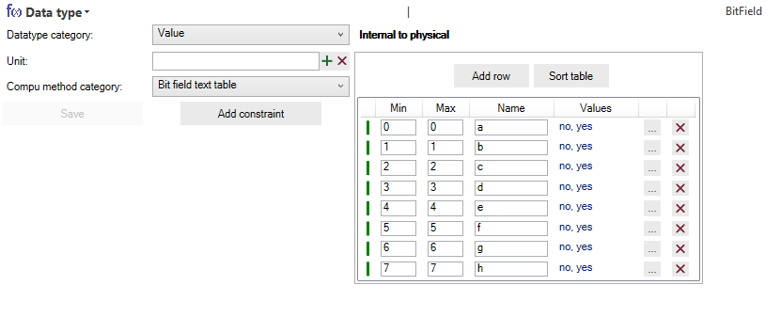  The interval type is considered to be CLOSED at all times.  To specify the values for each bit(s), click the button to the right of Values to access an editor.  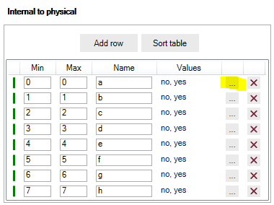  It is possible to set a value for each bit and also to move values depending on which bit value (1 or 0) they represent.  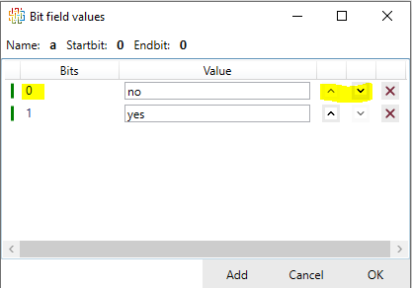  Note: It is not possible to save the bit field values if there are too many rows added.  For 1 bit (i.e., 0 - 0) there are two possible values: 1 and 0.  For 2 bits (i.e., 0 - 1) there are four possible values: 00, 01, 10, and 11. And so on.  There are built-in consistency checks, e.g.,:  - No duplicates of names  - Max < Min  - Min > Max  - Negative Min/Max  If an error occurs, this will be indicated in red in the indicator column to the far left. An explanation of the error is available via the hover tip:  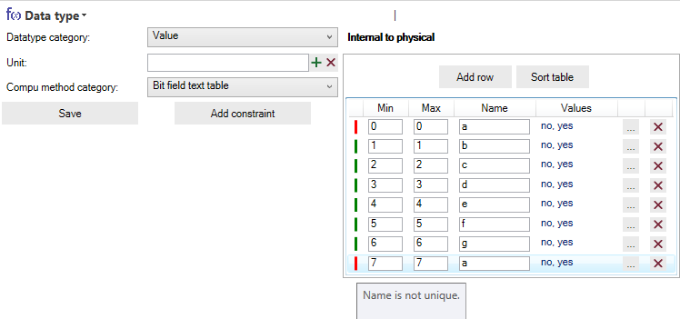  If errors exist, it is not possible to save the specification. | Improvement | Users | 15819
Issues Attachment Log: Fix for downloading | This fixes an issue with downloading an attachment to an Issue to local drive. | Bug fix | Users | 15565
Parts: Error info column disappears | The Error Info column now remains in view when you switch between items in a structure. | Bug fix | Users | 15769
CMS Charts: Support for issue type icons | There is now support for generating a CMS pie chart for issue types that have icons assigned. | Bug fix | Users | 15781
Configurable graph: Selection in tree when selecting port | This fixes an issue where the corresponding item in the tree structure for a selected port in the configured graph was not correctly being selected. | Bug fix | Users | 15511

