Name | Description | Issue ID | Type | User Group
Mirror: Unable to log into mirror server | This fixes an issue where a user whose account was created against the mirror server could not log in to the mirror server when a shared license was used. | 14232 | Bug fix | Administrator
swAdmin2: Export to Excel Save Dialog | When exporting the user list to Excel, the Save dialog will now be presented instead of the Open dialog.  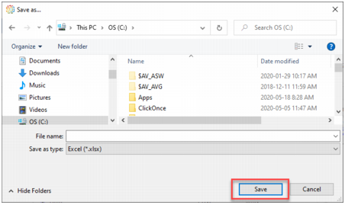 | 12195 | Enhancement | Administrator
swAdmin2: Improved license status | When there are insufficient licenses, the License status will clearly indicate this.  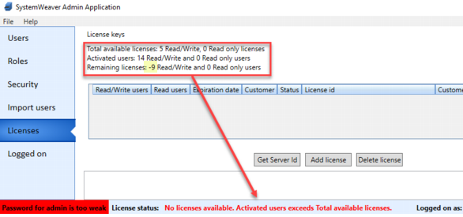 | 13931 | Enhancement | Administrator
swAdmin2: Improved open connections counters | Administrators can now get a clear, real-time count of active connections and actively used licenses on the Logged on tab.  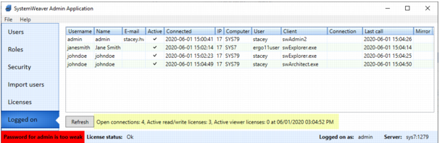  Open connections: Number of successful connections to the server  Active read/write licenses: Number of successful connections currently utilizing a read/write license  Active viewer licenses: Number of successful connections currently utilizing a read-only license | 13684, 14407 | Enhancement | Administrator
swAdmin2: Removal of unsuccessful logins | Previously, entries for unsuccessful login attempt remained hung on the Logged on screen in swAdmin2. They will now clear out so that only successful, active sessions will be displayed. | 12361 | Enhancement | Administrator
API: Item Status Colors | The associated colors for the statuses for items, i.e., work, freeze, release have been added to the C# API. | 14201 | Enhancement | API user
Extensions: Dedicated sub-folders | It is now possible to put extensions in dedicated sub-folders in the swExplorerExtensions directory, to allow for extensions with dependencies without merging with ilmerge or libz. The following five SystemWeaver files must be included in each sub-folder along with any referenced dlls:  - RemObjects.Hydra.dll  - RemObjects.Hydra.WPF.dll  - Systemite.SystemWeaver.ExtensionControls.dll  - SystemWeaverExtensionsAPI.dll | 14080 | Enhancement | API user
Extensions: VS template for MultiInstanceView | There is now a Visual Studios template available for MultiInstanceView. You can find all templates in the attachment uploaded to Getting Started With swExplorer Extensions. | 14133 | Enhancement | API User
REST API: Additional endpoints | There is now an endpoints in the REST API for the following:  - Creating issues  - Deleting issues  - Reading nodes | 14135, 14189, 14060 | Enhancement | API User
REST API: Additional parameter descriptions added | Parameter descriptions have been added for the following:  - Patch item status  - Post issue  - Post item  - Post Node | 14317, 14318, 14319, 14316 | Enhancement | API User
Grids/Tables: Script Language enhancements | A select attribute is now available for <RowObject> so that you can use a string value or a path query to obtain a string value as a result.  <RowObject name="" select=""/>  A new StringValueColumn is also available that works together with the above.  <StringValueColumn width="auto" caption="column name" objectName=".. "/>  In addition, the use of RowObject select=".." and StringValueColumn can replace the use of TextColumn with path query which will result in a performance improvement for grid generation. Also, the size of the definition becomes comparatively smaller and easier to follow.  Example:  <Table>  <Columns>  <ItemNameColumn width="200"/>  <StringValueColumn width="100" objectName="type"/>  </Columns>  <RowObject name="type" select="'case1'">  <Row/>  </RowObject>  </Table> | 14184, 14226 | Enhancement | Architect
Path language: VersionText | There is now support for the VersionText field code in the Path Query Language.  Return type  string  Valid for object  item  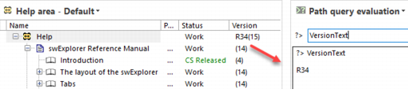 | 14344, 13756 | Enhancement | Architect
Grids: Improved grouping mechanism | The grouping mechanism in grids has been updated. This improvement will make inconsistency checks easier to review. | 14067, 14185, 13734 | Enhancement | Architect, User
Configurable graphs: Upgrade and improvements | The graph component has been upgraded from 2.5 to 3.2, and the calculation of node width has changed. Additional improvements are planned for the next release. | 13703 | Enhancement | Architect,User
Slave Server: Fix for out of sync issue | This fixes an issue where new events resulting from the mirror server were not entirely being handled correctly by the slave server. Note that the slave server is being deprecated in an upcoming release with the mirror server taking its place. | 14268 | Bug fix | IT Administrator
Server: Improved handling of out of sync | Improved handling of journaling when the connection between the main server and the database is lost during the commit stage. | 14130 | Bug fix | IT Adminitrator
Attachments: Clarification of file revision comment size | Comments added when uploading a new or revised attachment are limited to 100 characters. This limitation has been made clearer in the dialogs. 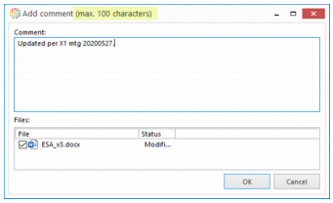 | 13928 | Bug fix | User
CMS: Ability to delete iteration | It is now possible to delete iterations in a CMS Project. Multi-select is supported.  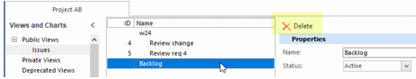  You can only delete an iteration if it does not contain any issues. | 14356 | Enhancement | User
CMS: Restrict issue deletion | It is now possible to restrict issue deletion using field="Delete" in a Project workflow configuration. As with other available restriction options, you can set this for a specific workflow status or all workflow statuses.  Example of Issue deletion not allowed if issue's Status=Closed:  <Workflow initialStatus="Started">  <Status name="Started">  <NextStatuses>  <NextStatus name="Closed"/>  </NextStatuses>  </Status>  <Status name="Closed">  <Restrictions>  <Restriction field="Delete" test="false"/>  </Restrictions>  </Status>  </Workflow>  The option will be grayed out for users.  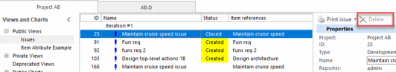 | 14346 | Enhancement | User
Custom time format causes swExplorer not to load | This fixes an issue where a custom time format set on the user machine caused the swExplorer to not load. | 14239 | Bug fix | User
Document: Table of Contents scaling issue in 150% | This fixes a scaling issue in Documents view and print preview when using display settings greater than 100%. | 14227 | Bug fix | User
ReqIF Export: Fix for access denied | This fixes an intermittent access denied error thrown when completing a ReqIF Export in Citrix environment. | 14072 | Bug fix | User
Versions view: Optimized default setting | We have optimized the initial loading of the Versions view by making the context version column hidden by default. Users wanting to show this optional column on an as-needed basis can select the option from either the right-click menu or header row menu.  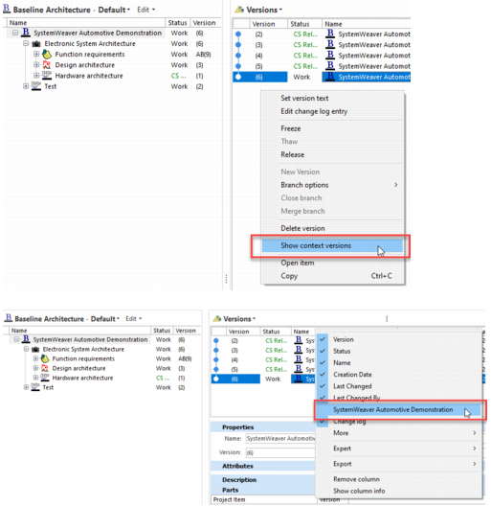 | 13488 | Enhancement | User
XhtmlDescription: Use relative file paths to images in xhtml | This fixes the file paths to images in the xhtml to ensure that they are always relative rather than absolute. | 14169 | Enhancement | User

