This document describes new features, improvements and fixes included in this release of SystemWeaver. An upgrade from an earlier version requires that all client and server applications be upgraded.

- SystemWeaver Server - Software and Hardware Requirements
- SystemWeaver Client - System Requirements

Note: Special attention should be given to the items highlighted in yellow as they will require additional planning/steps for your organization pre and/or post-upgrade if the view/tool affected is being used in your installation.

API Users
Name | Description | Type | User Group | Issue ID
API: Now available via NuGet | The SystemWeaver Client API is now available via a NuGet package. See How to Install the SystemWeaver.Connection NuGet Package on our Support Portal. | Improvement | API User | 13263
API: Performance improvement for low latency connections | The AP I now has a pure .Net implementation of the LZ4 compression algorithm. The SystemWeaver API requires .Net Framework 4.6 and .Net Core 2.2. | Improvement | API User | 12981
API: Use of API with .Net Core | The SystemWeaver Client API is now available for use in .Net Core which means you can now develop across platforms with the API. See Using the SystemWeaver Client API in .Net Core. It is available via NuGet. | Improvement | API User | 13287
Extension API: Ability to open issue | It is now possible to Open Issue using the Extension API.  Example:  IswIssue issue = AItem.Broker.FindIssueWithId("3");  _host.OpenIssue(issue); | Improvement | API User | 13118
Extension API: Improved icon method | There is a new method in the Extensions API for calculating the correct image index when referring to type images.  public int GetImageIndex()  {  return SystemWeaver.Resources.SWImages.TypeImageIndexToGuiImageIndex(1);  }  If you have returned an image index greater than 111, you need to change your code to use this method if you want the icon to remain unchanged after the upgrade. | Improvement | API User | 13238
Extension API: Introduction of MultiInstanceItemview extension type | There is now a new extension type, MultiInstanceItemView, which, like Item-view, adds a new item view to the specification view pane to the right of the structure tree. The difference is that it allows for multiple, simultaneous configured item views unlike Item-view which can have only one active instance. | Improvement | API User | 13235
API: Version update from 1.50 to 1.51 | The SystemWeaver API has been upgraded from version 1.50 to version 1.51. This will require that all users receive and utilize the R31 version of the client applications (swExplorer, swAdmin2, swArchitect). In addition, this requires that any API applications developed in-house will need to be recompiled with the newer version of the SystemWeaverClientAPI.dll. | Improvement | API User | 13327

Architects
Name | Description | Type | User Group | Issue ID
Configurable XML: Support for generating comments | There is now support for generating comments in generated XML output using <XComment> together with the <Text> tag. The text value may include SystemWeaver Field Codes.  Example:  <XDocument name="Doc1">  <XComment>  <Text>My comment</Text>  </XComment>  <XElement name="Section">  <XAttribute name="title" value="#{Name}"/>  <Text>Hello</Text>  </XElement>  </XDocument>  Result:  <Doc1>  <!-- My comment -->  <Section title="A">  Hello  </Section>  </Doc1> | Improvement | Architect | 12756
Coverage (mapping): Fix for PartAttributeColumn as additional column | This fixes an issue where adding the PartAttributeColumn as an additional primary or secondary column in the Coverage (mapping) view was not working properly. | Fix | Architect | 13124
Description templates: Support for icons | This fixes an error thrown when the Description Templates config item was assigned an icon. There is now support for the use of icons with Description Templates. | Fix | Architect | 13248
FaultTreeGraph: Ability to include FTA Minimal cut set in reports | It is now possible to include the FTA Minimal Cut Set table in reports using the tag <Extension name="MinimalCutSet">.  <Report>  <Extension name="MinimalCutSet"/>  </Report>  Note that the <Extension name="SWExtension.FaultTreeGraph" maxTreeHeight=""/> tag still exists for the FTA graph. | Improvement | Architect | 13123
Grid: Fix for editing NameColumn for Issues | This fixes an issue where users were unable to edit NameColumn when <RowObject> was used. | Fix | Architect | 13127
Grids and Tables: Display of XML attributes | It is now possible to have the content of an XML attribute display in a grid or table.  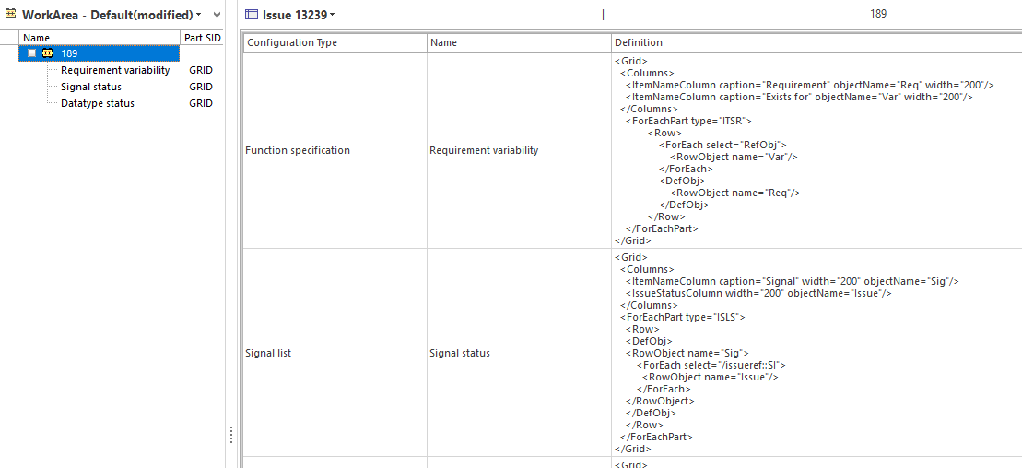 | Improvement | Architect | 13239
Icons: Image lists and view setting image option | Architects can now view lists of available GUI and Type icons in swExplorer. They can be found in Configure the explorer on the Checks tab.  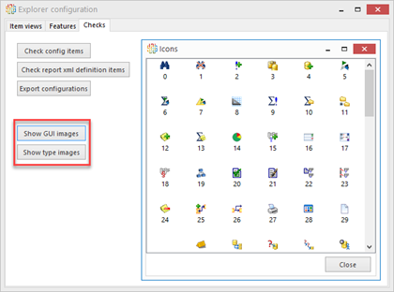  Show GUI images displays all icons available for multi-instance configurable views.  Show type images displays all icons available for types (i.e., items, parts) in the meta model and for multi-instance configurable views.  Images in both lists can be used for plugins.  For multi-instance configurable views, there is a new tag in ViewSettings called Image for defining the icon. Use guiImage for icons from the GUI images list and typeImage for icons from the Type images list.  Example  <ViewSettings>  <Caption>Allocate Reqs</Caption>  <RibbonGroup>Allocation</RibbonGroup>  <Description>Hint shown in the ribbon</Description>  <Image guiImage="90"/>  </ViewSettings>  Result  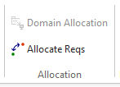 | Improvement | Architect | 13238
Meta Model Graph: Configuration option and Icon added | The Meta Model Graph view can now be used with or without configuration. Add a configuration if you would like to change the default styles. See Configure Meta Model Graphs view in the Help for more information.  In addition, the view now displays an icon.  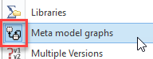 | Improvement | Architect | 12654, 12816
ReqIF: Xhtml description with image and & in file name throws error | This fixes an issue where an error was thrown when saving a ReqIF output file that included an image in a description and when the file name included a "&" symbol. | Fix | Architect | 13049
Ribbon: Ability to hide inactive button | There is now an optional setting called hideIfDisabled for buttons of types ItemView, MultiButton and MergeButton which allows you to define if an inactive button of these types should be hidden rather than grayed out. To hide when inactive, set the value to "true". If not configured, inactive buttons will display grayed out by default as before.  Example:  <RibbonGroup caption="">  <OpenItem id="" caption="" treeSettings=""/>  <OpenItem id="" caption="" hideIfDisabled=""/>  </RibbonGroup> | Improvement | Architect | 13212
Ribbon: Allow configuration of tree view setting for OpenItem button | It is now possible to specify the use of a structure tree view setting other than the Default* view setting when configuring an OpenItem button. Enter the name of the view setting in the treeSettings attribute. If no treeSettings attribute is specified, the behavior is unchanged, i.e., if the item is already open, it will become the active page without any view setting change.  Example:  <RibbonGroup caption="">  <OpenItem id="" caption="" treeSettings=""/>  <OpenItem id="" caption=""/>  </RibbonGroup>  *If you want to use the Default setting, you must specify it, i.e., treeSettings="Default". | Improvement | Architect | 13078
Ribbon: Fix for group menu visibility | This fixes an issue with how the visibility tag on buttons affects the visibility of the menu group. Now, if a group has only one button with visibility="Ignore" and it is inactive, the group will not be visible since there are then no visible buttons in the group. | Fix | Architect | 13211
swArchitect: Access violation in Meta model cutter | This fixes an access violation error thrown when you checkmark a part type for a selected item type. | Fix | Architect | 13221
XML Editor: Fix display of error message | This fixes an issue in the XML editor where error messages longer than 2 lines were not being displayed properly. A vertical scrollbar is now available. | Fix | Architect | 13295
XML Import: Match on ancestor | Fixes have been applied to XML Import to minimize the number of forced new versions. An import will now correctly:  - Ignore part ancestor id if it is not sufficient to match on.  - Identify branch items as later versions if they have the same foreign id | Fix | Architect | 13023, 13161, 13162, 13144, 12970
XML Import: Preview of item types | XML Import now provides a preview of the item type.  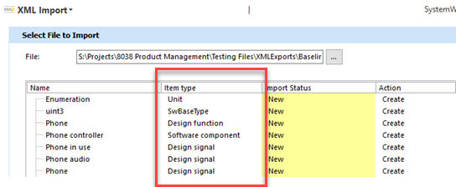 | Improvement | Architect | 12985
XML Export: Export configuration settings included | The exported XML file will now include the export configuration settings which can be useful information when planning an import.  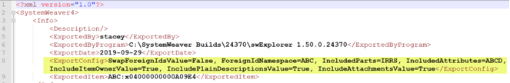  Potentially breaking change for imports if the receiving organization programmatically reads the XML data. Inform them of the new ExportConfig tag. | Improvement | Architect | 13163
swDatabaseManager: Remove older version options | The Database tab in the swDatabaseManager tool has gotten a face lift to make it easier to find the options you are looking for. Options relating to older database versions (i.e., earlier than 1.41) have been removed. In addition, two new tabs have been added - Mirroring and Legacy scripts. Mirroring will be utilized for the new generation slave server which will soon be available. The Legacy scripts tab provides access to older scripts. | Improvement | Architect | 12909, 13116

IT Administrators
Name | Description | Type | User Group | Issue ID
Server: Handling of exceptions in work queue | This fixes an issue with the handling of certain exceptions in the work queue. | Fix | IT Admin. | 13223
swDatabaseManager: Remove older version options | The Database tab in the swDatabaseManager tool has gotten a face lift to make it easier to find the options you are looking for. Options relating to older database versions (i.e., earlier than 1.41) have been removed. In addition, two new tabs have been added - Mirroring and Legacy scripts. Mirroring will be utilized for the new generation slave server which will soon be available. The Legacy scripts tab provides access to older scripts. | Improvement | IT Admin. | 12909, 13116
API: Version update from 1.50 to 1.51 | Although most machines will already have it installed, the SystemWeaver API requires that the server machine have.Net Framework (4.6) installed. | Improvement | IT Admin | 13327

Users
Name | Description | Type | User Group | Issue  ID
Attachments: Ability to add comments for all uploads | There are multiple ways to add new or revised attachment files in the Attachments view. You now have the option to add a comment each time you upload an attachment file whereas previously, this option was not available for all upload options. | Improvement | User | 13220
Attachments: Change log now shows file size | The change log for an attachment now displays the file size.  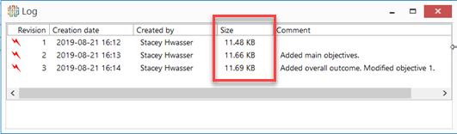 | Improvement | User | 13219
Attribute: Removal of edit/clear buttons for Computed Attributes | The edit and clear buttons have been removed for computed attributes. Since computed attributes cannot be edited, the display of these buttons caused confusion. | Improvement | User | 13056
Chart and Graph: Implementation of refresh using F5 | It is now possible to refresh a configurable chart or graph view when set as a primary or secondary view or undocked using the F5 shortcut. | Improvement | User | 12148, 12147
Client GUI: More modern look and feel for menu tabs | Throughout the swExplorer and swArchitect clients, you'll notice small changes to the look of the File menu and menu tabs.  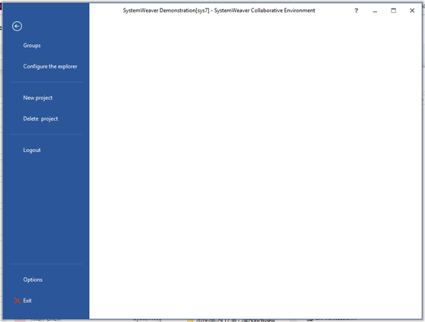  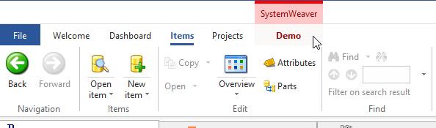 | Improvement | User | 13296, 13255
Component Graph: Icon added | The Component Graph standard extension view option now displays an icon.  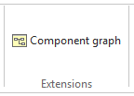 | Improvement | User | 12653
Configurable Graph: Fix for errors when double-clicking in graph | This fixes an issue where an error was thrown when double-clicking on sub-nodes and parts. This also includes a fix for unexpected panning of a node in the graph when moving the mouse in the view area. | Fix | User | 12036, 13214, 11783, 13215
Configurable Graph: Long node text cut-off | This fixes an issue where longer texts in nodes in the graph were being cut-off so that the entire text was not readible. | Fix | User | 12806
Coverage (mapping item): Ability to add and remove parts | The following edit options are now available in the Coverage (mapping item) view (if configured by an Architect).  - Create and add new parts for a selected item  - Add existing parts for a selected item  - Remove a part(s) for a selected item  - New Version and Replace when selecting an editable part that is pointing to a Released item.  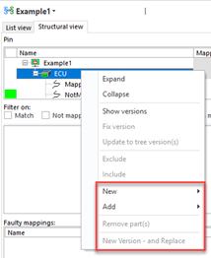  Configuration Example:  <PrimaryStructureTreeEditableParts partTypes="IBRA;3SBH"/>  <SecondaryStructureTreeEditableParts partTypes="IXRQ"/> | Improvement | User, Architect | 13102
Create new document from template: option label change | In the Create New Document from template dialog, the Create Copy menu option has been renamed Clone to avoid confusion with the standard Copy option in the context menu and for consistency with the Clone item view. | Improvement | User | 13145
Create test: Scaling issue hides buttons | This fixes an issue where the the buttons under the "Test System" and "System Under Test" sections in the Create test view were not scaling properly and, therefore, did not display at all in higher settings. | Fix | User | 13176
Description: Page width preview option | The page width option allows users to preview whether or not the content of a Description will fit within a specified page width configured, for example, for a document. They see a preview of what elements will be cut-off in the subsequent document output.  All content falling outside (to the right of) the indicator line will not be included in output with the selected page size nor in the Documents View (for Documents). This means that all portions of images and tables that do not fit within the page size work area to the left of the line will need to be manually resized to fit if it will be included in a generated Document or Report. Note that content must be to the left of the indicator line and not on top of it.  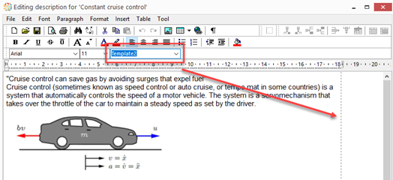  Text will automatically wrap within the page size area to the left of the indicator line as long as the Paragraph>Word Wrap setting is activated (this is the default setting in the editor).  Page width selection  By selecting a page width option in the drop-down in the Description editor, users can preview content with different, defined page widths.  - An option that is pre-selected for you is the system default. If configured, the default line will also appear in the embedded Description in the Overview view.  - You can make your own selection on-the-fly during viewing. Note that selections are only valid for the current viewing. The selection does not get saved.  - The indicator line is strictly a preview tool and has no effect on printing, e.g., page setup, print preview, printing.  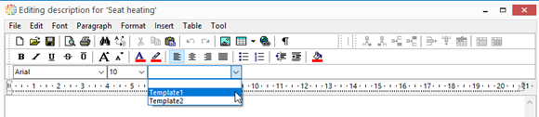  The options available are configured by Architect users. See Configure Description page width preview for configuration.  There are four options:  - No indicator line: No Description page width configuration. The page width preview will not be available to users.  - Page width selection without default: Page width view options available in the editor, but not implemented in the embedded Description.  - Page width selection with default: Page width view options available in the editor with a default value pre-selected, but ​not implemented in the embedded Description.  - Page width selection with default and preset in Overview: Page width view options available in the editor with a default value pre-selected, and indicator line displaying in the embedded Description.  Example configuration:  <PageWidthIndicators>  <Editor name="Template1" width="667"/>  <Editor name="Template2" width="687"/>  <Overview width="667"/>  <!--Editor name="Template3" width="667" default="true"-->  </PageWidthIndicators>  * The width attribute is defined in pixels. It must take into account if left and/or right margin options are defined in XMLs for documents/reports for the preview to be accurate. For example, if a document template with header table is configured for A4 with a 20 mm left margin, a matching page size preview option should be configured for the page size selection list in the editor. | Improvement | User, Architect | 13188, 13323
Description: Support for mathematical expressions | The Description editor now supports the creation of mathematical expressions.  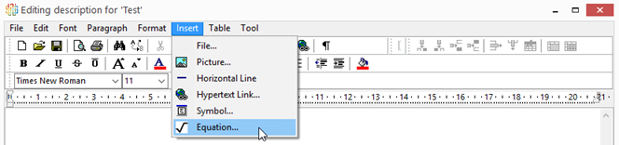  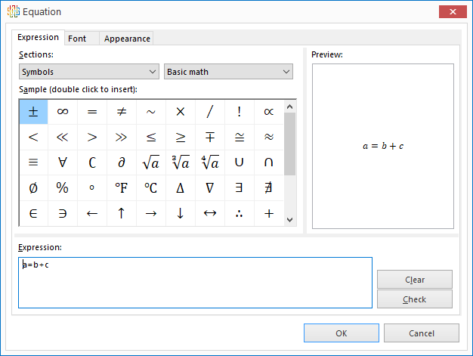  Important notice about compatibility  The display of mathematical expressions created using the Insert equation tool requires version R31 or later. If exchanging data with external organizations running SystemWeaver, those organizations must also upgrade and use version R31 or later of the swExplorer client as the mathematical expressions will not display in earlier versions. If data containing mathematical expressions is exchanged and edits are done using older versions of the swExplorer client, the equations will disappear. | Improvement | User | 12977
Documents: Problem with scaling | This fixes an issue where extension graphs and large pictures sometimes did not scale properly when included in Documents. | Fix | User | 12835
FaultTreeGraph: Fix for issue with access control | This fixes an issue related to library access when working with the extension. | Fix | User | 12455
FaultTreeGraph: Icon added for FTA | The Fault Tree Analysis extension view option now displays an icon.  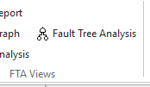 | Improvement | User | 12625
Help: F1 redirect not consistently working | This fixes an issue where using F1 to open the application Help did not always redirect to the context-specific section. | Fix | User | 11946
OccurrenceAttribute Column: Display of enum attribute value color | Enum part attribute values will now display attribute value color when using OccurrenceAttributeColumn in reports and grids in the same way as with the regular attribute columns.  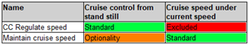 | Improvement | User | 12930
Page tabs: Additional navigation option | If you have more tabs open than can be displayed properly on your screen, you will see only the tabs for which there is room to display. All open tabs, however, are listed when using the button. With R31, there are now left and right navigation buttons that can also be used to bring hidden, open tabs back into view.  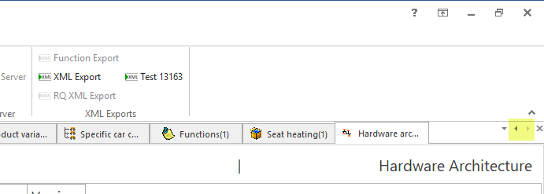 | Improvement | User | 13148
Projects: Fix for issue editor resizing problem | This fixes an issue on the Projects tab where the issue editor could become partially "hidden" behind the issue list with no way to resize it to view the entire contents. | Fix | User | 12713
Requirements: Ability to multi-select requirements | It is now possible to multi-select requirements for the Specifying item in the Requirements view used in the Test domain.  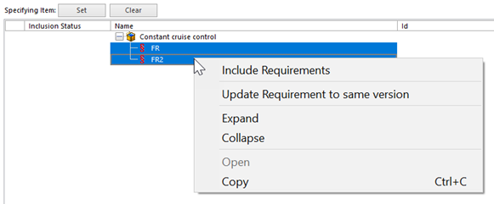 | Improvement | User | 13139
Test Case Editor: Add sequence button missing in higher display setting | This fixes an issue where the Add sequence button in the Test Case Editor view would not display with higher Windows display settings. | Fix | User | 13237
Versions: Handling of merge conflicts | Merge conflicts are now handled using a right-click context menu instead of the previous control buttons. Conflicts are indicated with orange in the new Conflict column. The conflict options are Keep trunk and Change to branch.  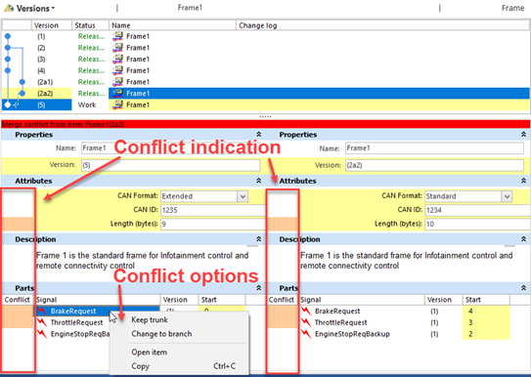 | Improvement | User | 13141
Versions: Incomplete highlighting of differences in compare | This fixes an issue where some differences between two versions were not always properly highlighted. | Fix | User | 13241
Versions: Merge does not identify conflict for part attributes with null value | This fixes an issue where the Merge branch option in the Versions view did not properly identify a conflict for part attributes when the common ancestor was empty. | Fix | User | 13150

