This document describes new features, improvements and fixes included in this release of SystemWeaver. An upgrade from an earlier version requires that all client and server applications be upgraded.

- SystemWeaver Server - Software and Hardware Requirements
- SystemWeaver Client - System Requirements

Note: Special attention should be given to the items highlighted in yellow as they will require additional planning/steps for your organization pre and/or post-upgrade if the view/tool affected is being used in your installation.

Name | Description | Type | User Group | Issue ID
Description: Configurable page width indicator line | The line type, color and thickness of the optional Description Page Width indicator line is now configurable using an EdgeStyle tag similar to the one used in node graphs to configure edges.  Example  <PageWidthIndicators>  <Editor name="Template1" width="667" default="true">  <EdgeStyle thickness="10" color="Red" lineType="Solid"/>  </Editor>  <Editor name="Template2" width="687"/>  <Overview width="667">  <EdgeStyle thickness="10" color="Red" lineType="Solid"/>  </Overview>  </PageWidthIndicators>  Result  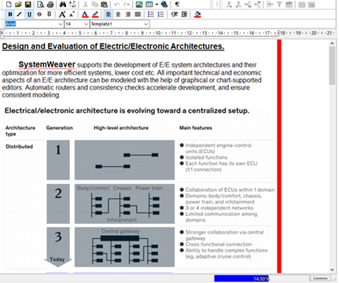  If not configured, the default EdgeStyle will apply (thickness "1", color "Gray", and style "Dash"). | Improvement | Architect | 13557
Description: Indicator line placement with changed scaling | This fixes an issue where the Description page width indicator line placement changed when display settings were changed. It will now remain in position between 17 and 18 on the ruler in the Description editor regardless of display scaling. | Fix | User | 13556
Feature Modelling: New extension view | The Feature Model Editor view is now a plugin and various improvements have been made, such as:  - Expand and collapse of tree  - Focus remains where you are working when creating features, etc.  - Ability to rename items directly in the view  See Working with Feature Modelling. | Improvement | Architect, User | 10741
HARA: New Hazard identification extension views | With Release R32, a new version of the Hazard Identification solution is introduced. See Introduction to Hazard Analysis and Risk Assessment (HARA). | Improvement | Architect, User | 13473
Introduction of REST API v1 | Systemite is proud to announce the first version of the SystemWeaver REST API. For more information, see Introduction to the SystemWeaver REST API Server. | New | API user | 13427
Projects: Support for read-only issues | It is now possible to configure restrictions in Project workflows resulting in all or specific elements, e.g., properties, attributes, relationships, etc. of an issue becoming read-only for a specific Status in the Workflow or for all Statuses. Restrictions are applied by project and effect all members of the project unless specifically configured otherwise.  Example:  <Workflow>  <All>  <Restrictions>  <Restriction field="*" test="CurrentUser = AssignedTo"/>  <Restriction field="Attribute:ABAN" test="CurrentUser = AssignedTo"/>  <Restriction field="Attachments" test="CurrentUser = AssignedTo"/>  <Restriction field="Relationship:IR" test="CurrentUser = AssignedTo"/>  <Restriction field="Notes" test="CurrentUser = AssignedTo"/>  </Restrictions>  </All>  </Workflow>  For more information, refer to the "Workflows" section in the Help manual. | Improvement | Administrator | 13512
Projects: Use of CurrentUser in Issue Views | It is now possible to use CurrentUser to filter Issue views where the current user is a value in a User type of attribute. Whereas (single) User and set of User were previously interpreted as strings, they are now correctly interpreted as users.  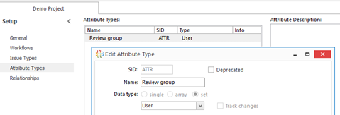  <View>  <Columns>  <IssueIDColumn align="right"/>  <NameColumn width="300"/>  </Columns>  <Filter>  <Satisfies test="CurrentUser in @ATTR"/>  </Filter>  </View> | Improvement | Administrator, User, Breaking change | 13291
Ribbon: ItemView option to automatically reference latest version | For ribbon configuration of Item Views that include configItem, it is now possible to use the SID of the configured type along with a defined id instead of the specific xID of a config item version. In this way, button configurations do not need to be updated manually should a new version of a config item be made. When using the configured type SID and defined id, the button will automatically point to the latest version of the config item.  Example:  A report is configured for items of type CNDE. The report has been given an id value of "ConsistRprt". The resulting Ref id is used in the button configuration. When a new version of the report is made, this Ref id value remains constant (unless the id is manually changed to another valid id value).  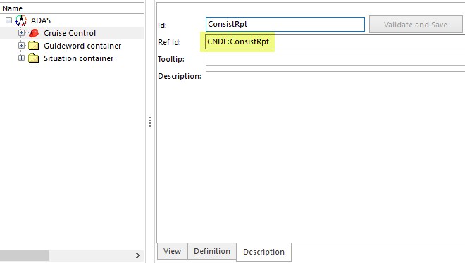  <MergeButton caption="Safety report" image="55">  <ItemView name="Report" configItem="CNDE:ConsistRpt"/>  <ItemView name="Report" configItem="x3400000000001DE5"/>  </MergeButton>  Note: To utilize this new option for ItemViews, you must first load Item ribbon tab metadata in Configure the explorer.  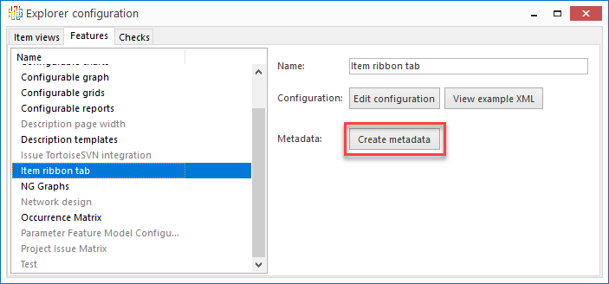 | Improvement | Architect | 13083
Server: Availability of statistics log | The Systemite.SystemWeaver.TcpSubServer.exe.nlog now offers a logging option for user operations and user statistics. The log is JSON formated and can easily be read, analyzed and visualized using an external tool of choice, such as ELK (Elasticsearch, Logstash, and Kibana). Note that as with any logging, sufficient disk space must be available for storing the files. | New | Administrator | 13555, 13576, 13552, 13581, 13588
Variability Matrix: Support for description | The Variability Matrix view now includes the Description field. Users can select a part in the view and read its Description while scrolling through the matrix.  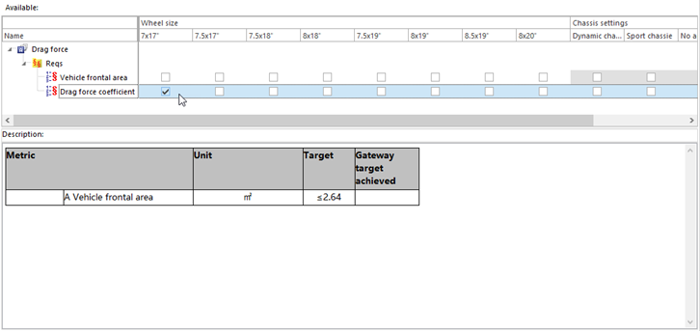 | Improvement | User | 13193
View Icons: Display icon in View drop-down list | For item views and extension views* that allow for multiple configurations, the configured image will now display in the View drop-down as well.  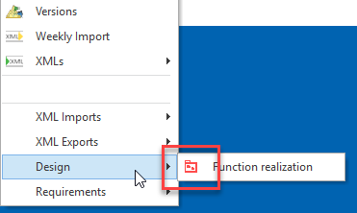  * The extension must include proper image configuration. | Improvement | Architect | 13526
XML Export: Export of enum value color and text | When exporting a meta model that includes enumeration attribute values that have color and Description text, the colors and description texts will now be included in the export and can then be imported into another server.  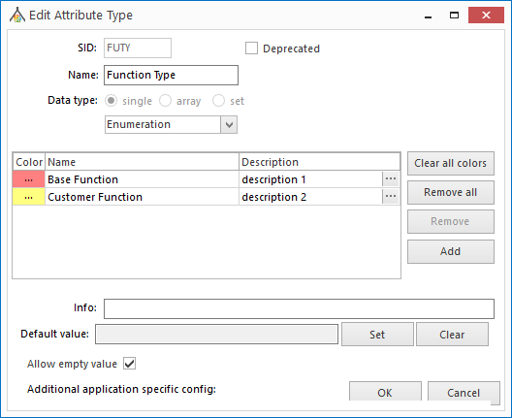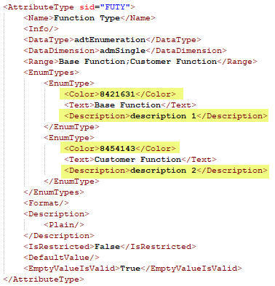 | Improvement | Architect | 11873
XML Import: Improvements to meta model import | New features of the meta model import now means full support for incremental extensions of a SystemWeaver meta model, through XML import:  - Update the list of default attributes for an existing item type  - Update the formatted text descriptions of types (item/part/attributes)  - Update the detailed information of attribute enumeration types (i.e. the colors and value descriptions)  In addition, the XML generation now supports generation of the format used for the path expression of Computed attributes (i.e. zipped and uuencoded CDATA) from Text format, using the new <AttributePathData> tag, meaning that complete SystemWeaver meta models can be generated by the SystemWeaver XML view, and with the improvements listed above, also imported as complete meta models, with no need for subsequent hands-on modifications. | Improvement | Architect | 11872, 12797, 12808, 11873
swArchitect: Fix for data error | This fixes an issue where a data error was thrown in the swArchitect after refactoring an attribute's data dimension when a default value was set. | Fix | Architect | 13244
swArchitect: GUI update for Float and Integer attributes | The Numeric range option for Float and Integer attribute types has been removed to avoid confusion as this option is not currently supported | Fix | Architect | 13043

